UNIT -II
Process Concept: Process scheduling, Operations on processes, Inter-process
Communication , Communication in client server systems.
***
Early computers allowed only one program to be executed at a time. This program had complete control of the system and had access to all the system’s resources. In contrast, contemporary computer systems allow multiple programs to be loaded into memory and executed concurrently. This evolution required firmer control and more compartmentalization of the various programs; and these needs resulted in the notion of a process, which is a program in execution. A process is the unit of work in a modern time-sharing system.
The more complex the operating system is, the more it is expected to do on behalf of its users. Although its main concern is the execution of user programs, it also needs to take care of various system tasks that are better left outside the kernel itself. A system therefore consists of a collection of processes: operating system processes executing system code and user processes executing user code. Potentially, all these processes can execute concurrently, with the CPU (or CPUs) multiplexed among them. By switching the CPU between processes, the operating system can make the computer more productive. In this chapter, you will read about what processes are and how they work.
***
PROCESS CONCEPT:
A program in execution is called a process.
A batch system executes jobs, whereas a time-shared be able to run several programs at one time: a word processor, aWeb browser, and an e-mail package. And even if a user can execute only one program at a time, such as on an embedded device that does not support multitasking, the operating system may need to support its own internal programmed activities, such as memory management. In many respects, all these activities are similar, so we call all of them processes.
The terms job and process are used almost interchangeable. Although we personally prefer the term process, much of operating-system theory and terminology was developed during a time when the major activity of operating systems was job processing. It would be misleading to avoid the use of commonly accepted terms that include the word job (such as job scheduling) simply because process has superseded job.
The Process
Informally, as mentioned earlier, a process is a program in execution. A process is more than the program code, which is sometimes known as the text section. It also includes the current activity, as represented by the value of the program counter and the contents of the processor’s registers. A process generally also includes the process stack, which contains temporary data (such as function parameters, return addresses, and local variables), and a data section, which contains global variables. A process may also include a heap, which is memory that is dynamically allocated during process run time. The structure of a process in memory is shown in below Figure.
Figure: Process in memory.
We emphasize that a program by itself is not a process. A program is a passive entity, such as a file containing a list of instructions stored on disk (often called an executable file). In contrast, a process is an active entity, with a program counter specifying the next instruction to execute and a set of associated resources. A program becomes a process when an executable file is loaded into memory. Two common techniques for loading executable files are double-clicking an icon representing the executable file and entering the name of the executable file on the command line (as in prog.exe or a.out).
Although two processes may be associated with the same program, they are nevertheless considered two separate execution sequences. For instance, several users may be running different copies of the mail program, or the same user may invoke many copies of the web browser program. Each of these is a separate process; and although the text sections are equivalent, the data, heap, and stack sections vary. It is also common to have a process that spawns many processes as it runs.
Note that a process itself can be an execution environment for other code. The Java programming environment provides a good example. In most circumstances, an executable Java program is executed within the Java virtual machine (JVM). The JVM executes as a process that interprets the loaded Java code and takes actions (via native machine instructions) on behalf of that code. For example, to run the compiled Java program Program.class, we would enter
java Program
The command java runs the JVM as an ordinary process, which in turns executes the Java programin the virtual machine. The concept is the same as simulation, except that the code, instead of being written for a different instruction set, is written in the Java language.

Process States:
As a process executes, it changes state. The state of a process is defined in part by the current activity of that process. A process may be in one of the following states:

- New. The process is being created.
- Running. Instructions are being executed.
- Waiting. The process is waiting for some event to occur (such as an I/O completion or reception of a signal).
- Ready. The process is waiting to be assigned to a processor.
- Terminated. The process has finished execution.
These names are arbitrary, and they vary across operating systems. The states that they represent are found on all systems, however. Certain operating systems also more finely delineate process states. It is important to realize that only one process can be running on any processor at any instant. Many processes may be ready and waiting, however. The state diagram corresponding to these states is presented in following Figure.

Figure:Diagram of process state.

Process Control Block:

Each process is represented in the operating system by a process control block (PCB)—also called a task control block. A PCB is shown in below Figure. It contains many pieces of information associated with a specific process, including these:
Figure: Process control block (PCB)
- Process state. The state may be new, ready, running, waiting, halted, and so on.
- Program counter. The counter indicates the address of the next instruction to be executed for this process.
- CPU registers. The registers vary in number and type, depending on the computer architecture. They include accumulators, index registers, stack pointers, and general-purpose registers, plus any condition-code information. Along with the program counter, this state information must be saved when an interrupt occurs, to allow the process
- be continued correctly afterward.
- CPU-scheduling information. This information includes a process priority, pointers to scheduling queues, and any other scheduling parameters.
- Memory-management information. This information may include such items as the value of the base and limit registers and the page tables, or the segment tables, depending on the memory system used by the operating system.
- Accounting information. This information includes the amount of CPU and real time used, time limits, account numbers, job or process numbers, and so on.
- I/O status information. This information includes the list of I/O devices allocated to the process, a list of open files, and so on. In brief, the PCB simply serves as the repository for any information that may vary from process to process.

Figure: Diagram showing CPU switch from process to process.

Threads:

The process model discussed so far has implied that a process is a program that performs a single thread of execution. For example, when a process is running a word-processor program, a single thread of instructions is being executed. This single thread of control allows the process to perform only one task at a time. The user cannot simultaneously type in characters and run the spell checker within the same process, for example. Most modern operating systems have extended the process concept to allow a process to have multiple threads of execution and thus to perform more than one task at a time. This feature is especially beneficial on multicore systems, where multiple threads can run in parallel. On a system that supports threads, the PCB is expanded to include information for each thread. Other changes throughout the system are also needed to support threads.

***

Process Scheduling:

The objective of multiprogramming is to have some process running at all times, to maximize CPU utilization. The objective of time sharing is to switch the CPU among processes so frequently that users can interact with each program while it is running. To meet these objectives, the process scheduler selects an available process (possibly from a set of several available processes) for program execution on the CPU. For a single-processor system, there will never be more than one running process. If there are more processes, the rest will have to wait until the CPU is free and can be rescheduled.

Scheduling Queues:
As processes enter the system, they are put into a job queue, which consists of all processes in the system. The processes that are residing in main memory and are ready and waiting to execute are kept on a list called the ready queue. This queue is generally stored as a linked list. A ready-queue header contains pointers to the first and final PCBs in the list. Each PCB includes a pointer field that points to the next PCB in the ready queue.

The system also includes other queues. When a process is allocated the CPU, it executes for a while and eventually quits, is interrupted, or waits for the occurrence of a particular event, such as the completion of an I/O request. Suppose the process makes an I/O request to a shared device, such as a disk. Since there are many processes in the system, the disk may be busy with the I/O request of some other process. The process therefore may have to wait for the disk. The list of processes waiting for a particular I/O device is called a device queue. Each device has its own device queue.

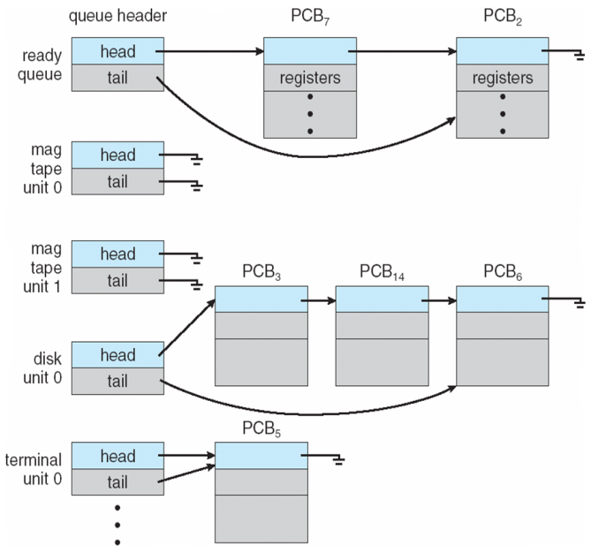
Figure: The ready queue and various I/O device queues.

A common representation of process scheduling is a queueing diagram, such as that in below Figure. Each rectangular box represents a queue. Two types of queues are present: the ready queue and a set of device queues. The circles represent the resources that serve the queues, and the arrows indicate the flow of processes in the system.

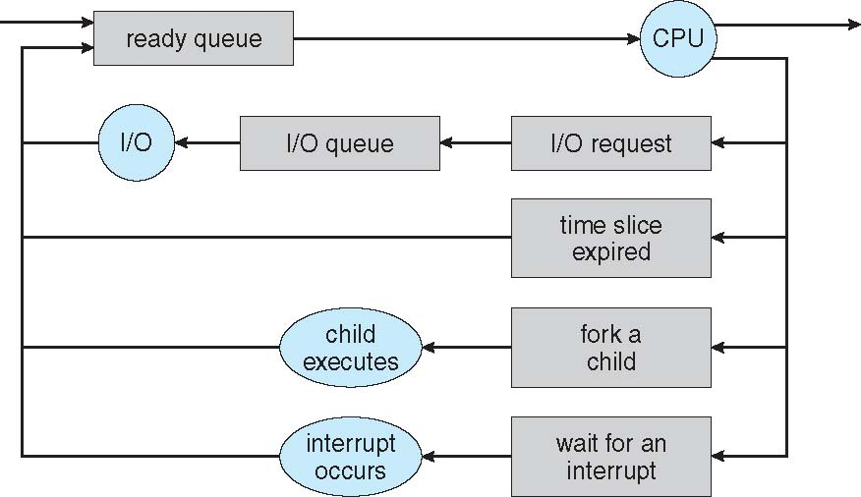

Figure: Queueing-diagram representation of process scheduling.

A new process is initially put in the ready queue. It waits there until it is selected for execution, or dispatched. Once the process is allocated the CPU and is executing, one of several events could occur:

- The process could issue an I/O request and then be placed in an I/O queue.
- The process could create a new child process and wait for the child’s termination.
- The process could be removed forcibly from the CPU, as a result of an interrupt, and be put back in the ready queue.
In the first two cases, the process eventually switches from the waiting state to the ready state and is then put back in the ready queue. A process continues this cycle until it terminates, at which time it is removed from all queues and has its PCB and resources deallocated.

Schedulers:

A process migrates among the various scheduling queues throughout its lifetime. The operating system must select, for scheduling purposes, processes from these queues in some fashion. The selection process is carried out by the appropriate scheduler.

Often, in a batch system, more processes are submitted than can be executed immediately. These processes are spooled to a mass-storage device (typically a disk), where they are kept for later execution. The long-term scheduler, or job scheduler, selects processes from this pool and loads them into memory for execution. The short-term scheduler, or CPU scheduler, selects from among the processes that are ready to execute and allocates the CPU to one of them.

The primary distinction between these two schedulers lies in frequency of execution. The short-term scheduler must select a new process for the CPU frequently. A process may execute for only a few milliseconds before waiting for an I/O request. Often, the short-term scheduler executes at least once every 100 milliseconds. Because of the short time between executions, the short-term scheduler must be fast. If it takes 10 milliseconds to decide to execute a process
for 100 milliseconds, then 10/(100 + 10) = 9 percent of the CPU is being used (wasted) simply for scheduling the work.

The long-term scheduler executes much less frequently; minutes may separate the creation of one new process and the next. The long-term scheduler controls the degree of multiprogramming (the number of processes in memory). If the degree of multiprogramming is stable, then the average rate of process creation must be equal to the average departure rate of processes leaving the system. Thus, the long-term scheduler may need to be invoked only when a process leaves the system. Because of the longer interval between executions, the long-term scheduler can afford to take more time to decide which process should be selected for execution.
It is important that the long-term scheduler make a careful selection. In general, most processes can be described as either I/O bound or CPU bound. An I/O-bound process is one that spends more of its time doing I/O than it spends doing computations. A CPU-bound process, in contrast, generates I/O requests infrequently, using more of its time doing computations. It is important that the long-term scheduler select a good process mix of I/O-bound and CPU-bound processes. If all processes are I/O bound, the ready queue will almost always be empty, and the short-term scheduler will have little to do.If all processes are CPU bound, the I/O waiting queue will almost always be empty, devices will go unused, and again the system will be unbalanced. The system with the best performance will thus have a combination of CPU-bound and I/O-bound processes.

On some systems, the long-term scheduler may be absent or minimal. For example, time-sharing systems such as UNIX and Microsoft Windows systems often have no long-term scheduler but simply put every new process in memory for the short-term scheduler. The stability of these systems depends either on a physical limitation (such as the number of available terminals)
or on the self-adjusting nature of human users. If performance declines to unacceptable levels on a multiuser system, some users will simply quit.
Some operating systems, such as time-sharing systems, may introduce an additional, intermediate level of scheduling. This medium-term scheduler is diagrammed in Figure 3.7. The key idea behind a medium-term scheduler is that sometimes it can be advantageous to remove a process from memory (and from active contention for the CPU) and thus reduce the degree of multiprogramming. Later, the process can be reintroduced into memory, and its
execution can be continued where it left off. This scheme is called swapping. The process is swapped out, and is later swapped in, by the medium-term scheduler. Swapping may be necessary to improve the process mix or because a change in memory requirements has overcommitted available memory, requiring memory to be freed up. Swapping is discussed in Chapter 8.

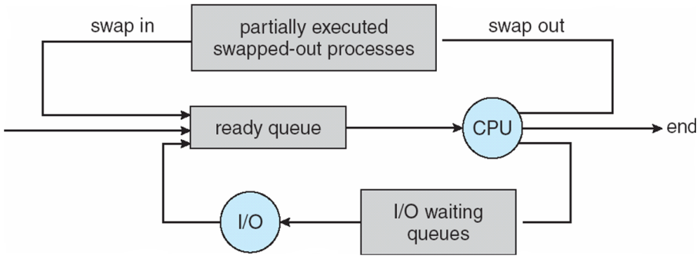
Figure: Addition of medium-term scheduling to the queueing diagram.

Context Switch:

Interrupts cause the operating system to change a CPU from its current task and to run a kernel routine. Such operations happen frequently on general-purpose systems. When an interrupt occurs, the system needs to save the current context of the process running on the CPU so that it can restore that context when its processing is done, essentially suspending the process and then resuming it. The context is represented in the PCB of the process. It includes the value of the CPU registers, the process state and memory-management information. Generically, we perform a state save of the current state of the CPU, be it in kernel or user mode, and then a state restore to resume operations.

Switching the CPU to another process requires performing a state save of the current process and a state restore of a different process. This task is known as a context switch. When a context switch occurs, the kernel saves the context of the old process in its PCB and loads the saved context of the new process scheduled to run. Context-switch time is pure overhead, because the system does no useful work while switching. Switching speed varies from machine to machine, depending on the memory speed, the number of registers that must be copied, and the existence of special instructions (such as a single instruction to load or store all registers). A typical speed is a few milliseconds.

Context-switch times are highly dependent on hardware support. For instance, some processors (such as the Sun UltraSPARC) provide multiple sets of registers. A context switch here simply requires changing the pointer to the current register set. Of course, if there are more active processes than there are register sets, the system resorts to copying register data to and from memory, as before. Also, the more complex the operating system, the greater the amount of work that must be done during a context switch.

***

Schedulers: (Simplified)
Schedulers are special system software which handles process scheduling in various ways. Their main task is to select the jobs to be submitted into the system and to decide which process to run. Schedulers are of three types −
- Long-Term Scheduler
- Short-Term Scheduler
- Medium-Term Scheduler

Long Term Scheduler
It is also called a job scheduler. A long-term scheduler determines which programs are admitted to the system for processing. It selects processes from the queue and loads them into memory for execution. Process loads into the memory for CPU scheduling.
The primary objective of the job scheduler is to provide a balanced mix of jobs, such as I/O bound and processor bound. It also controls the degree of multiprogramming. If the degree of multiprogramming is stable, then the average rate of process creation must be equal to the average departure rate of processes leaving the system.
On some systems, the long-term scheduler may not be available or minimal. Time-sharing operating systems have no long term scheduler. When a process changes the state from new to ready, then there is use of long-term scheduler.

Short Term Scheduler
It is also called as CPU scheduler. Its main objective is to increase system performance in accordance with the chosen set of criteria. It is the change of ready state to running state of the process. CPU scheduler selects a process among the processes that are ready to execute and allocates CPU to one of them.
Short-term schedulers, also known as dispatchers, make the decision of which process to execute next. Short-term schedulers are faster than long-term schedulers.

Medium Term Scheduler
Medium-term scheduling is a part of swapping. It removes the processes from the memory. It reduces the degree of multiprogramming. The medium-term scheduler is in-charge of handling the swapped out-processes.
A running process may become suspended if it makes an I/O request. A suspended process cannot make any progress towards completion. In this condition, to remove the process from memory and make space for other processes, the suspended process is moved to the secondary storage. This process is called swapping, and the process is said to be swapped out or rolled out. Swapping may be necessary to improve the process mix.

Comparison among Scheduler:

S.N. | Long-Term Scheduler | Short-Term Scheduler | Medium-Term Scheduler
1 | It is a job scheduler | It is a CPU scheduler | It is a process swapping scheduler.
2 | Speed is lesser than short term scheduler | Speed is fastest among other two | Speed is in between both short and long term scheduler.
3 | It controls the degree of multiprogramming | It provides lesser control over degree of multiprogramming | It reduces the degree of multiprogramming.
4 | It is almost absent or minimal in time sharing system | It is also minimal in time sharing system | It is a part of Time sharing systems.
5 | It selects processes from pool and loads them into memory for execution | It selects those processes which are ready to execute | It can re-introduce the process into memory and execution can be continued.

***

Operations on Processes:

The processes in most systems can execute concurrently, and they may be created and deleted dynamically. Thus, these systems must provide a mechanism for process creation and termination.

- Process creation
- Process termination

Process Creation

During the execution, a process may create several new processes. As mentioned earlier, the creating process is called a parent process, and the new processes are called the children of that process. Each of these new processes may in turn create other processes, forming a tree of processes.

Most operating systems (including UNIX, Linux, and Windows) identify processes according to a unique process identifier (or pid), which is typically an integer number. The pid provides a unique value for each process in the system, and it can be used as an index to access various attributes of a process within the kernel.

Figure: A tree of processes on a typical Linux system.

Above figure illustrates a typical process tree for the Linux operating system, showing the name of each process and its pid. (We use the term process rather loosely, as Linux prefers the term task instead.) The init process (which always has a pid of 1) serves as the root parent process for all user processes. Once the system has booted, the init process can also create various user processes, such as a web or print server, an ssh server, and the like.

In Figure, we see two children of init — kthreadd and sshd. The kthreadd process is responsible for creating additional processes that perform tasks on behalf of the kernel (in this situation, khelper and pdflush). The sshd process is responsible for managing clients that connect to the system by using ssh (which is short for secure shell).

The login process is responsible for managing clients that directly log onto the system. In this example, a client has logged on and is using the bash shell, which has been assigned pid 8416. Using the bashcommand-line interface, this user has created the process ps as well as the emacs editor.

On UNIX and Linux systems, we can obtain a listing of processes by using the ps command. For example, the command

ps –el

will list complete information for all processes currently active in the system. It is easy to construct a process tree similar to the one shown in Figure, by recursively tracing parent processes all the way to the initprocess.

In general, when a process creates a child process, that child process will need certain resources (CPU time, memory, files, I/O devices) to accomplish its task. A child process may be able to obtain its resources directly from the operating system, or it may be constrained to a subset of the resources of the parent process. The parent may have to partition its resources among its children, or it may be able to share some resources (such as memory or files) among several of its children. Restricting a child process to a subset of the parent’s resources prevents any process from overloading the system by creating too many child processes.

In addition to supplying various physical and logical resources, the parent process may pass along initialization data (input) to the child process. For example, consider a process whose function is to display the contents of a file —say, image.jpg—on the screen of a terminal. When the process is created, it will get, as an input from its parent process, the name of the file image.jpg. Using that file name, it will open the file and write the contents out. It may also get the name of the output device. Alternatively, some operating systems pass resources to child processes. On such a system, the new process may get two open files, image.jpg and the terminal device, and may simply transfer the datum between the two.

When a process creates a new process, two possibilities for execution exist:

- The parent continues to execute concurrently with its children.

- The parent waits until some or all of its children have terminated.

There are also two address-space possibilities for the new process:

- The child process is a duplicate of the parent process (it has the same program and data as the parent).
- The child process has a new program loaded into it.

To illustrate these differences, let’s first consider the UNIX operating system. In UNIX, as we’ve seen, each process is identified by its process identifier, which is a unique integer. A new process is created by the fork() system call. The new process consists of a copy of the address space of the original process. This mechanism allows the parent process to communicate easily with its child process. Both processes (the parent and the child) continue execution at the instruction after the fork(), with one difference: the return code for the fork() is zero for the new (child) process, whereas the (nonzero) process identifier of the child is returned to the parent.

After a fork() system call, one of the two processes typically uses the exec() system call to replace the process’s memory space with a new program. The exec() system call loads a binary file into memory (destroying the memory image of the program containing the exec() system call) and starts its execution. In this manner, the two processes are able to communicate and then go their separate ways. The parent can then create more children; or, if it has nothing else to do while the child runs, it can issue a wait() system call to move itself off the ready queue until the termination of the child. Because the call to exec() overlays the process’s address space with a new program, the call to exec() does not return control unless an error occurs.

Figure: Creating a separate process using the UNIX fork() system call.

The above c program illustrates the UNIX system calls previously described. We now have two different processes running copies of the same program. The only difference is that the value of pid (the process identifier) for the child process is zero, while that for the parent is an integer value greater than zero (in fact, it is the actual pid of the child process). The child process inherits privileges and scheduling attributes from the parent, as well certain resources, such as open files. The child process then overlays its address space with the UNIX command /bin/ls (used to get a directory listing) using the execlp() system call (execlp() is a version of the exec() system call). The parent waits for the child process to complete with the wait() system call. When the child process completes (by either implicitly or explicitly invoking exit()), the parent process resumes from the call to wait(), where it completes using the exit() system call. This is also illustrated in below figure

Figure: Process creation using the fork() system call.

There is nothing to prevent the child from not invoking exec() and instead continuing to execute as a copy of the parent process. In this scenario, the parent and child are concurrent processes running the same code instructions. Because the child is a copy of the parent, each process has its own copy of any data.

As an alternative example, we next consider process creation in Windows. Processes are created in the Windows API using the CreateProcess() function, which is similar to fork() in that a parent creates a new child process. However, whereas fork() has the child process inheriting the address space of its parent, CreateProcess() requires loading a specified program into the address space of the child process at process creation. Furthermore, whereas fork() is passed no parameters, CreateProcess() expects no fewer than ten parameters.

The Following C program illustrates the CreateProcess() function, which creates a child process that loads the application mspaint.exe. We opt for many of the default values of the ten parameters passed to CreateProcess().

The two parameters passed to the CreateProcess() function are instances of the STARTUPINFO and PROCESS INFORMATION structures. STARTUPINFO specifies many properties of the new process, such as window size and appearance and handles to standard input and output files. The PROCESS INFORMATION structure contains a handle and the identifiers to the newly created process and its thread. We invoke the ZeroMemory() function to allocate memory for each of these structures before proceeding with CreateProcess().

Figure: Creating a separate process using the Windows API.
The first two parameters passed to CreateProcess() are the application name and command-line parameters. If the application name is NULL (as it is in this case), the command-line parameter specifies the application to load. In this instance, we are loading the MicrosoftWindows mspaint.exe application. Beyond these two initial parameters, we use the default parameters for inheriting process and thread handles aswell as specifying that there will be no creation flags.We also use the parent’s existing environment block and starting directory. Last, we provide two pointers to the STARTUPINFO and PROCESS - INFORMATION structures created at the beginning of the program. Generally, the parent process waits for the child to complete by invoking the wait() system call. The equivalent of this in Windows is WaitForSingleObject(), which is passed a handle of the child process—pi.hProcess—and waits for this process to complete. Once the child process exits, control returns from the WaitForSingleObject() function in the parent process.

Process Termination

A process terminates when it finishes executing its final statement and asks the operating system to delete it by using the exit()system call. At that point, the process may return a status value (typically an integer) to its parent process (via the wait() system call). All the resources of the process—including physical and virtual memory, open files, and I/O buffers—are deallocated by the operating system.

Termination can occur in other circumstances as well. They are

A process can cause the termination of another process via an appropriate system call (for example, TerminateProcess()inWindows). Usually, such a system call can be invokedonly by the parent of the process that is to be terminated.

Otherwise, users could arbitrarily kill each other’s jobs. Note that a parentneeds to know the identities of its children if it is to terminate them. Thus, when one process creates a new process, the identity of the newly created process is passed to the parent.

A parent may terminate the execution of one of its children for a variety of reasons, such as these:

- The child has exceeded its usage of some of the resources that it has been allocated.
- The task assigned to the child is no longer required.
- The parent is exiting, and the operating system does not allow a child to continue if its parent terminates.

Some systems do not allow a child to exist if its parent has terminated. In such systems, if a process terminates (either normally or abnormally), then all its children must also be terminated. This phenomenon, referred to as cascading termination, is normally initiated by the operating system.

To illustrate process execution and termination, consider that, in Linux and UNIX systems, we can terminate a process by using the exit() system call, providing an exit status as a parameter:

/* exit with status 1 */
exit(1);

In fact, under normal termination, exit() may be called either directly (as shown above) or indirectly (by a return statement in main()).

A parent process may wait for the termination of a child process by using the wait() system call. The wait() system call is passed a parameter that allows the parent to obtain the exit status of the child. This system call also returns the process identifier of the terminated child so that the parent can tell which of its children has terminated:

pid t pid;
int status;
pid = wait(&status);

When a process terminates, its resources are deallocated by the operating system. However, its entry in the process table must remain there until the parent calls wait(), because the process table contains the process’s exit status.

A process that has terminated, butwhose parent has not yet called wait(), is known as a zombie process. All processes transition to this state when they terminate, but generally they exist as zombies only briefly. Once the parent calls wait(), the process identifier of the zombie process and its entry in the process table are released.

Now consider what would happen if a parent did not invoke wait() and instead terminated, thereby leaving its child processes as orphans. Linux and UNIX address this scenario by assigning the init process as the new parent to orphan processes. The init process periodically invokes wait(), thereby allowing the exit status of any orphaned process to be collected and releasing the orphan’s process identifier and process-table entry.

***

Interprocess Communication:

Processes executing concurrently in the operating system may be either independent processes or cooperating processes. A process is independent if it cannot affect or be affected by the other processes executing in the system. Any process that does not share data with any other process is independent. A process is cooperating if it can affect or be affected by the other processes executing in the system. Clearly, any process that shares data with other processes is a cooperating process.

There are several reasons for providing an environment that allows process cooperation:

• Information sharing. Since several users may be interested in the same piece of information (for instance, a shared file), we must provide an environment to allow concurrent access to such information.
• Computation speedup. Ifwewant a particular task to run faster,wemust break it into subtasks, each of which will be executing in parallel with the others. Notice that such a speedup can be achieved only if the computer has multiple processing cores.
• Modularity. We may want to construct the systemin a modular fashion, dividing the system functions into separate processes or threads, as we discussed in Chapter 2.
• Convenience. Even an individual user may work on many tasks at the same time. For instance, a user may be editing, listening to music, and compiling in parallel.

Cooperating processes require an interprocess communication (IPC) mechanism that will allow them to exchange data and information. There are two fundamental models of interprocess communication: shared memoryand message passing. In the shared-memorymodel, a region ofmemory that is shared by cooperating processes is established. Processes can then exchange information by reading and writing data to the shared region. In the message-passing model, communication takes place by means of messages exchanged between the cooperating processes. The two communications models are shown in following figure

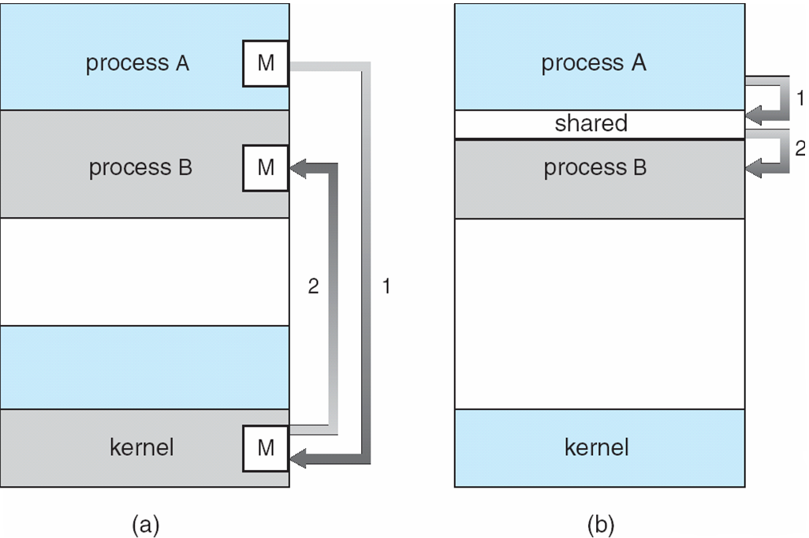

Figure:Communications models. (a) Message passing. (b) Shared memory.

Both of the models just mentioned are common in operating systems, and many systems implement both. Message passing is useful for exchanging smaller amounts of data, because no conflicts need be avoided. Message passing is also easier to implement in a distributed system than shared memory. (Although there are systems that provide distributed shared memory,wedo not consider them in this text.) Shared memory can be faster than message passing, since message-passing systems are typically implemented using system calls and thus require the more time-consuming task of kernel intervention. In shared-memory systems, system calls are required only to establish shared memory regions. Once shared memory is established, all accesses are treated as routine memory accesses, and no assistance from the kernel is required. Recent research on systems with several processing cores indicates that message passing provides better performance than shared memory on such systems. Shared memory suffers from cache coherency issues, which arise because shared data migrate among the several caches. As the number of processing cores on systems increases, it is possible that we will see message passing as the preferred mechanism for IPC.

Shared-Memory Systems

Interprocess communication using shared memory requires communicating processes to establish a region of shared memory. Typically, a shared-memory region resides in the address space of the process creating the shared-memory segment. Other processes that wish to communicate using this shared-memory segment must attach it to their address space. Recall that, normally, the operating system tries to prevent one process from accessing another process’s memory. Shared memory requires that two or more processes agree to remove this restriction. They can then exchange information by reading and writing data in the shared areas. The form of the data and the location are determined by these processes and are not under the operating system’s control. The processes are also responsible for ensuring that they are not writing to the same location simultaneously.

To illustrate the concept of cooperating processes, let’s consider the producer–consumer problem, which is a common paradigm for cooperating processes. A producer process produces information that is consumed by a consumer process. For example, a compiler may produce assembly code that is consumed by an assembler. The assembler, in turn, may produce object modules that are consumed by the loader. The producer–consumer problem also provides a useful metaphor for the client–server paradigm.We generally think of a server as a producer and a client as a consumer. For example, a web server produces (that is, provides) HTML files and images, which are consumed (that is, read) by the client web browser requesting the resource. One solution to the producer–consumer problem uses shared memory. To allow producer and consumer processes to run concurrently, we must have available a buffer of items that can be filled by the producer and emptied by the consumer. This buffer will reside in a region of memory that is shared by the producer and consumer processes. A producer can produce one item while the consumer is consuming another item. The producer and consumer must be synchronized, so that the consumer does not try to consume an item that has not yet been produced.

Two types of buffers can be used. The unbounded buffer places no practical limit on the size of the buffer. The consumer may have to wait for new items, but the producer can always produce new items. The bounded buffer assumes a fixed buffer size. In this case, the consumermustwait if the buffer is empty, and the producer must wait if the buffer is full. Let’s look more closely at how the bounded buffer illustrates interprocess communication using shared memory. The following variables reside in a region of memory shared by the producer and consumer processes:

The shared buffer is implemented as a circular array with two logical pointers: in and out. The variable in points to the next free position in the buffer; out points to the first full position in the buffer. The buffer is empty when in == out; the buffer is fullwhen ((in + 1) % BUFFER SIZE) == out.

The code for the producer process and the code for the consumer process is shown in Figures. The producer process has alocal variable next produced in which the new item to be produced is stored. The consumer process has a local variable next consumed in which the item to be consumed is stored.

Figure: The producer process using shared memory.

Figure: The consumer process using shared memory.

3.4.2 Message-Passing Systems

cooperating processes can communicate in a shared-memory environment. The scheme requires that these processes share a region of memory and that the code for accessing and manipulating the shared memory be written explicitly by the application programmer. Another way to achieve the same effect is for the operating system to provide the means for cooperating processes to communicate with each other via a message-passingfacility.

Message passing provides a mechanism to allow processes to communicateand to synchronize their actions without sharing the same address space. It isparticularly useful in a distributed environment, where the communicatingprocesses may reside on different computers connected by a network. Forexample, an Internet chat program could be designed so that chat participantscommunicate with one another by exchanging messages.

Amessage-passing facility provides at least two operations:

- send(message)
- receive(message)

Messages sent by a process can be either fixed or variable in size. If only fixed-sized messages can be sent, the system-level implementation is straightforward. This restriction, however, makes the task of programming more difficult. Conversely, variable-sized messages require a more complex system level implementation, but the programming task becomes simpler. This is a common kind of tradeoff seen throughout operating-system design.

If processes P andQwant to communicate, theymust send messages to and receive messages from each other: a communication link must exist between them. This link can be implemented in a variety of ways.We are concerned here not with the link’s physical implementation (such as shared memory, hardware bus, or network, which are covered in Chapter 17) but rather with its logical implementation. Here are several methods for logically implementing a link and the send()/receive() operations:

• Direct or indirect communication
• Synchronous or asynchronous communication
• Automatic or explicit buffering
We look at issues related to each of these features next.

Naming

Processes that want to communicate must have a way to refer to each other. They can use either direct or indirect communication.

Under direct communication, each process that wants to communicate must explicitly name the recipient or sender of the communication. In this scheme, the send() and receive() primitives are defined as:

• send(P, message)—Send a message to process P.
• receive(Q, message)—Receive a message from process Q.

A communication link in this scheme has the following properties:

• A link is established automatically between every pair of processes that want to communicate. The processes need to know only each other’s identity to communicate.
• A link is associatedwith exactly two processes.
• Between each pair of processes, there exists exactly one link.

This scheme exhibits symmetry in addressing; that is, both the sender process and the receiver process must name the other to communicate. A variant of this scheme employs asymmetry in addressing. Here, only the sender names the recipient; the recipient is not required to name the sender. In this scheme, the send() and receive() primitives are defined as follows:

• send(P, message)—Send a message to process P.
• receive(id, message)—Receive a message from any process.

Thevariable id is set to the name of the process with which communication has taken place.

The disadvantage in both of these schemes (symmetric and asymmetric)is the limited modularity of the resulting process definitions. Changing the identifier of a process may necessitate examining all other process definitions. All references to the old identifier must be found, so that they can be modified to the new identifier.

In indirect communication, themessages are sent to and received from mailboxes, or ports.Amailbox canbe viewedabstractly as anobject intowhich messages can be placed by processes and fromwhichmessages can be removed. Each mailbox has a unique identification. For example, POSIX message queues use an integer value to identify a mailbox. A process can communicate with another process via a number of different mailboxes, but two processes can communicate only if they have a shared mailbox. The send() and receive() primitives are defined as follows:

• send(A, message)—Send a message to mailbox A.
• receive(A, message)—Receive a message from mailbox A.

In this scheme, a communication link has the following properties:

• A link is established between a pair of processes only if both members of the pair have a shared mailbox.
• A linkmay be associated withmore than two processes.
• Between each pair of communicating processes, a number of different links may exist, with each link corresponding to one mailbox.

Now suppose that processes P1, P2, and P3 all share mailbox A. Process P1 sends a message to A, while both P2 and P3 execute a receive() from A. Which process will receive the message sent by P1? The answer depends on which of the following methods we choose:

• Allow a link to be associated with two processes at most.
• Allow at most one process at a time to execute a receive() operation.
• Allow the system to select arbitrarily which process will receive the message (that is, either P2 or P3, butnotboth,will receive themessage).

The system may define an algorithm for selecting which process will receive the message (for example, round robin, where processes take turns receiving messages). The system may identify the receiver to the sender.

A mailboxmay be owned either by a process or by the operating system. If the mailbox is owned by a process (that is, the mailbox is part of the address space of the process), then we distinguish between the owner (which can only receive messages through this mailbox) and the user (which can only send messages to the mailbox). Since each mailbox has a unique owner, there can be no confusion about which process should receive a message sent to this mailbox. When a process that owns a mailbox terminates, the mailboxdisappears. Any process that subsequently sends a message to this mailbox must be notified that the mailbox no longer exists. In contrast, a mailbox that is owned by the operating system has an existence of its own. It is independent and is not attached to any particular process. The operating system then must provide a mechanism that allows a process to do the following:

• Create a new mailbox.
• Send and receive messages through the mailbox.
• Delete a mailbox.

The process that creates a new mailbox is that mailbox’s owner by default.Initially, the owner is the only process that can receive messages through this mailbox. However, the ownership and receiving privilege may be passed to other processes through appropriate system calls. Of course, this provision could result in multiple receivers for each mailbox.
Synchronization

Communication between processes takes place through calls to send() and receive() primitives. There are different design options for implementing each primitive. Message passing may be either blocking or nonblocking— also known as synchronous and asynchronous. (Throughout this text, you will encounter the concepts of synchronous and asynchronous behavior in relation to various operating-system algorithms.)

• Blocking send. The sending process is blocked until the message is received by the receiving process or by the mailbox.
• Nonblocking send. The sending process sends the message and resumes operation.
• Blocking receive. The receiver blocks until amessage is available.
• Nonblocking receive. The receiver retrieves either a valid message or a null.

Different combinations of send() and receive() are possible.When both send() and receive() are blocking, we have a rendezvous between the sender and the receiver. The solution to the producer–consumer problem becomes trivial when we use blocking send() and receive() statements. The producer merely invokes the blocking send() call and waits until the message is delivered to either the receiver or the mailbox. Likewise, when the consumer invokes receive(), it blocks until a message is available.

Buffering

Whether communication is direct or indirect, messages exchanged by communicating processes reside in a temporary queue. Basically, such queues can be
implemented in three ways:

message next produced;
while (true) {
/* produce an item in next produced */

send(next produced);
}

Figure 3.15 The producer process using message passing.

• Zero capacity. The queue has a maximum length of zero; thus, the link cannot have any messageswaiting in it. In this case, the sender must block until the recipient receives the message.
• Bounded capacity. The queue has finite length n; thus, at most n messages can reside in it. If the queue is not full when a new message is sent, the message is placed in the queue (either the message is copied or a pointer to the message is kept), and the sender can continue execution without waiting. The link’s capacity is finite, however. If the link is full, the sender must block until space is available in the queue.
• Unbounded capacity. The queue’s length is potentially infinite; thus, any number of messages can wait in it. The sender never blocks. The zero-capacity case is sometimes referred to as a message system with no buffering. The other cases are referred to as systems with automatic buffering.

***
Examples of IPC Systems:

An Example: POSIX Shared Memory:
Several IPC mechanisms are available for POSIX systems, including shared memory and message passing. Here, we explore the POSIX API for shared memory.
POSIX shared memory is organized using memory-mapped files, which associate the region of shared memory with a file. A process must first create a shared-memory object using the shm open() system call, as follows:
shm fd = shm open(name, O_CREAT | O_RDRW, 0666);
The first parameter specifies the name of the shared-memory object. Processes that wish to access this shared memory must refer to the object by this name. The subsequent parameters specify that the shared-memory object is to be created if it does not yet exist (O_CREAT) and that the object is open for reading and writing (O_RDRW). The last parameter establishes the directory permissions of the shared-memory object. A successful call to shm_open() returns an integer file descriptor for the shared-memory object.
Once the object is established, the ftruncate() function is used to configure the size of the object in bytes. The call
ftruncate(shm_fd, 4096);
sets the size of the object to 4,096 bytes.
Finally, the mmap() function establishes a memory-mapped file containing the shared-memory object. It also returns a pointer to the memory-mapped file that is used for accessing the shared-memory object.
The producer–consumer model in implementing shared memory. The producer establishes a shared memory object and writes to shared memory, and the consumer reads from shared memory.
The producer, creates a shared-memory object named OS and writes the infamous string "Hello World!" to shared memory. The program memory-maps a shared-memory object of the specified size and allows writing to the object. (Obviously, only writing is necessary for the producer.) The flag MAP SHARED specifies that changes to the shared-memory object will be visible to all processes sharing the object. Notice that we write to the shared-memory object by calling the sprintf() function and writing the formatted string to the pointer ptr. After each write, we must increment the pointer by the number of bytes written.

The consumer process,reads and outputs the contents of the shared memory. The consumer also invokes the shm unlink() function, which removes the shared-memory segment after the consumer has accessed it.

***

An Example: Mach
As an example of message passing, we next consider the Mach operatingsystem.The Mach kernel supports the creation and destructionof multiple tasks, which are similar to processes but have multiple threadsof control and fewer associated resources. Most communication in Mach—including all inter task information—is carried out by messages. Messages are sent to and received from mailboxes, called ports in Mach.
Even system calls are made by messages. When a task is created, two special mailboxes—the Kernel mailbox and the Notify mailbox—are also created. The kernel uses the Kernel mailbox to communicate with the task and sends notification of event occurrences to the Notify port. Only three system calls are needed for message transfer. The msg send() call sends a message to a mailbox. A message is received via msg receive(). Remote procedure calls (RPCs) are executed via msg rpc(), which sends a message and waits for exactly one return message from the sender. In this way, the RPC models atypical subroutine procedure call but can work between systems—hence the term remote.
The port_allocate() system call creates a new mailbox and allocates space for its queue of messages. The maximum size of the message queue defaults to eight messages. The task that creates the mailbox is that mailbox’s owner. The owner is also allowed to receive from the mailbox. Only one task at a time can either own or receive from a mailbox, but these rights can be sent to other tasks.
The mailbox’s message queue is initially empty. As messages are sent to the mailbox, the messages are copied into the mailbox. All messages have the same priority. Mach guarantees that multiple messages from the same sender are queued in first-in, first-out (FIFO) order but does not guarantee an absolute ordering. For instance, messages from two senders may be queued in any order.
The messages themselves consist of a fixed-length header followed by avariable-length data portion. The header indicates the length of the message and includes two mailbox names. One mailbox name specifies the mailbox reply, so the mailbox name of the sender is passed on to the receiving task,which can use it as a “return address.”
The variable part of a message is a list of typed data items. Each entry in the list has a type, size, and value. The type of the objects specified in the message is important, since objects defined by the operating system—such as ownership or receive access rights, task states, and memory segments—maybe sent in messages.
The send and receive operations themselves are flexible. For instance, when a message is sent to a mailbox, the mailbox may be full. If the mailbox is not full, the message is copied to the mailbox, and the sending thread continues. If the mailbox is full, the sending thread has four options:
1. Wait indefinitely until there is room in the mailbox.
2. Wait at most n milliseconds.
3. Do not wait at all but rather return immediately.
4. Temporarily cache a message. Here, a message is given to the operating system to keep, even though the mailbox to which that message is being sent is full. When the message can be put in the mailbox, a message is sent back to the sender. Only one message to a full mailbox can be pending at any time for a given sending thread.
The final option is meant for server tasks, such as a line-printer driver. After finishing a request, such tasks may need to send a one-time reply to the task that requested service, but they must also continue with other service requests ,even if the reply mailbox for a client is full.
The receive operation must specify the mailbox or mailbox set from which a message is to be received. A mailbox set is a collection of mailboxes, as declared by the task, which can be grouped together and treated as one mailbox for the purposes of the task. Threads in a task can receive only from a mailbox ormailbox set for which the task has receive access. A port status() system call returns the number of messages in a given mailbox. The receive operation attempts to receive from (1) any mailbox in a mailbox set or (2) a specific(named) mailbox. If no message is waiting to be received, the receiving thread can either wait at most n milliseconds or not wait at all.
The major problem with message systems has generally been poor performance caused by double copying of messages: the message is copied first from the sender to the mailbox and then from the mailbox to the receiver. The Mach message system attempts to avoid double-copy operations by using virtual-memory-management techniques. Essentially, Mach maps the address space containing the sender’s message into the receiver’s addres space. The message itself is never actually copied. This message-management technique provides a large performance boost but works for only intra system messages.

***

An Example: Windows

The Windows operating system is an example of modern design that employs modularity to increase functionality and decrease the time needed to implement new features. Windows provides support for multiple operating environments, or subsystems. Application programs communicate with these subsystems via a message-passing mechanism. Thus, application program scan be considered clients of a subsystem server.

The message-passing facility in Windows is called the advanced local procedure call (ALPC) facility. It is used for communication between two processes on the same machine. It is similar to the standard remote procedure call (RPC) mechanism that is widely used, but it is optimized for and specific to Windows. (Remote procedure calls are covered in detail in Section 3.6.2.)Like Mach, Windows uses a port object to establish and maintain a connection between two processes.

Windows uses two types of ports:
- connection ports
- communication ports.

Server processes publish connection-port objects that are visible to all processes. When a client wants services from a subsystem, it opens a handle to the server’s connection-port object and sends a connection request to that port.The server then creates a channel and returns a handle to the client. The channelconsists of a pair of private communication ports: one for client—servermessages, the other for server—client messages. Additionally, communicationchannels support a callback mechanism that allows the client and server toaccept requests when they would normally be expecting a reply.When an ALPC channel is created, one of three message-passing techniques
is chosen:
1. For small messages (up to 256 bytes), the port’s message queue is usedas intermediate storage, and the messages are copied from one process tothe other.
2. Larger messages must be passed through a section object, which is aregion of shared memory associated with the channel.
3. When the amount of data is too large to fit into a section object, an API isavailable that allows server processes to read and write directly into theaddress space of a client.

The client has to decide when it sets up the channel whether it will needto send a large message. If the client determines that it does want to sendlarge messages, it asks for a section object to be created. Similarly, if the serverdecides that replies will be large, it creates a section object. So that the sectionobject can be used, a small message is sent that contains a pointer and sizeinformation about the section object. This method is more complicated thanthe first method listed above, but it avoids data copying. The structure ofadvanced local procedure calls in Windows is shown in Figure 3.19.It is important to note that the ALPC facility in Windows is not part of theWindows API and hence is not visible to the application programmer. Rather,applications using the Windows API invoke standard remote procedure calls.When the RPC is being invoked on a process on the same system, the RPC ishandled indirectly through an ALPC. procedure call. Additionally,many kernel
services use ALPC to communicate with client processes.

References:

Abraham Silberschatz, Greg Gagne, and Peter Baer Galvin, "Operating System Concepts, Ninth Edition "

UNIT II
Multithreaded Programming: Multithreading models, Thread libraries, Threading issues,
Examples.
***
Threads:
Overview:

- A thread is a basic unit of CPU utilization; it comprises a thread ID, a program counter, a register set, and a stack.
- It shares with other threads belonging to the same process its code section, data section and other operating-system resources, such as open files and signals.
- A traditional (or heavyweight) process has a single thread of control. If a process has multiple threads of control, it can perform more than one task at a time.
- Following Figure illustrates the difference between a traditional single-threaded process and a multithreaded process.

Most software applications that run on modern computers are multithreaded. An application typically is implemented as a separate process with several threads of control.

A web browser might have one thread display images or text while another thread retrieves data from the network, for example. A word processor may have a thread for displaying graphics, another thread for responding to keystrokes from the user, and a third thread for performing spelling and grammar checking in the background.Such applications can perform several CPU-intensive tasks in parallel across the multiple computing cores.
In certain situations, a single application may be required to perform several similar tasks. For example, a web server accepts client requests for web pages, images, sound, and so forth. A busy web server may have several (perhaps thousands of) clients concurrently accessing it. If the web server ran as a traditional single-threaded process, it would be able to service only one client at a time, and a client might have to wait a very long time for its request to be serviced.
One solution is to have the server run as a single process that accepts requests. When the server receives a request, it creates a separate process to service that request. But, Process creation is time consuming and resource intensive, to overcome this overhead, It is generally more efficient to use one process that contains multiple threads. If the web-server process is multithreaded, the server will create a separate thread that listens for client requests. When a request is made, rather than creating another process, the server creates a new thread to service the request and resume listening for additional requests. This is illustrated in Figure 4.2.
Figure 4.2 Multithreaded server architecture
Benefits

The benefits of multithreaded programming can be broken down into four major categories:

- Responsiveness
- Resource sharing
- Economy
- Scalability

1. Responsiveness:
Multithreading an interactive application may allow a program to continue running even if part of it is blocked or is performing a lengthy operation, thereby increasing responsiveness to the user.

2. Resource sharing:
Processes canonly share resources throughtechniques such as shared memory and message passing. Such techniques must be explicitly arranged by the programmer. However, threads share the memory and the resources of the process to which they belong by default. The benefit of sharing code and data is that it allows an application to have several different threads of activity within the same address space.

3. Economy:
Allocatingmemoryandresources forprocess creationis costly. Because threads share the resources of the process to which they belong, it is more economical to create and context-switch threads.

4. Scalability:
The benefits of multithreading can be even greater in a multiprocessor architecture, where threads may be running in parallel on different processing cores. A single-threaded process can run on only one processor, regardless how many are available.
***
Multicore Programming:
Earlier in the history of computer design, in response to the need for more computing performance, single-CPU systems evolved into multi-CPU systems.

A more recent, similar trend in systemdesign is to placemultiple computing cores on a single chip. Each core appears as a separate processor to the operating system. Whether the cores appear across CPU chips or within CPU chips, we call these systems multicore or multiprocessor systems.

Multithreaded programming provides a mechanism for more efficient use of these multiple computing cores and improved concurrency.

Consider an application with four threads. On a system with a single computing core, concurrency merely means that the execution of the threads will be interleaved over time (Figure 4.3), because the processing core is capable of executing only one thread at a time. On a system with multiple cores, however, concurrency means that the threads can run in parallel, because the system can assign a separate thread to each core (Figure 4.4).

Figure 4.3 concurrent executions on a single-core system.
Figure 4.4 Parallel execution on a multicore system.

There is a distinction between parallelism and concurrency. A system is parallel if it can perform more than one task simultaneously. In contrast, a concurrent system supports more than one task by allowing all the tasks to make progress. Thus, it is possible to have concurrency without parallelism. CPU schedulers were designed to provide the illusion of parallelism by rapidly switching between processes in the system, thereby allowing each process to make progress. Such processes were running concurrently, but not in parallel.

Programming Challenges

In general, five areas present challenges in programming for multicore systems:
1. Identifying tasks. This involves examining applications to find areasthat can be divided into separate, concurrent tasks. Ideally, tasks areindependent of one another and thus can run in parallel on individualcores.

2. Balance. While identifying tasks that can run in parallel, programmersmust also ensure that the tasks perform equal work of equal value. Insome instances, a certain task may not contribute as much value to theoverall process as other tasks. Using a separate execution core to run thattask may not be worth the cost.

3. Data splitting. Just as applications are divided into separate tasks, thedata accessed and manipulated by the tasks must be divided to run onseparate cores.

4. Data dependency. The data accessed by the tasksmust be examined fordependencies between two or more tasks. When one task depends ondata from another, programmers must ensure that the execution of thetasks is synchronized to accommodate the data dependency.

5. Testing and debugging. When a program is running in parallel onmultiple cores, many different execution paths are possible. Testing anddebugging such concurrent programs is inherently more difficult thantesting and debugging single-threaded applications.

Types of Parallelism:

There are two types of parallelism:
- Data Parallelism
- Task Parallelism

Data parallelism focuses on distributing subsets of the same data across multiple computing cores and performing the same operation on each core. Consider, for example, summing the contents of an array of size N. On a single-core system, one thread would simply sum the elements [0] . . . [N − 1]. On a dual-core system, however, thread A, running on core 0, could sum the elements [0] . . . [N/2 − 1] while thread B, running on core 1, could sum the elements [N/2] . . . [N − 1]. The two threads would be running in parallel on separate computing cores.

Task parallelism involves distributing not data but tasks (threads) across multiple computing cores. Each thread is performing a unique operation. Different threads may be operating on the same data, or they may be operating on different data. Consider again our example above. In contrast to that situation, an example of task parallelism might involve two threads, each performing a unique statistical operation on the array of elements. The threads again are operating in parallel on separate computing cores, but each is performing a unique operation.
***
Multithreading Models

There are two types of threads:
- User threads
- Kernel threads

Support for threads may be provided either at the user level, for user threads, or by the kernel, for kernel threads. User threads are supported above the kernel and are managed without kernel support, whereas kernel threads are supported and managed directly by the operating system. Virtually all contemporary operating systems—including Windows, Linux, Mac OS X, and Solaris— support kernel threads.

Ultimately, a relationship must exist between user threads and kernel threads. Three common ways of establishing such a relationship are:
- The many-to-one model,
- The one-to-one model
- The many-to-many model.
Many-to-One Model
Figure 4.5 Many-to-one model
The many-to-one model (Figure 4.5) maps many user-level threads to one kernel thread. Thread management is done by the thread library in user space, so it is efficient.
The entire process will block if a thread makes a blocking system call. Also, because only one thread can access the kernel at a time,multiple threads are unable to run in parallel on multicore systems. Green threads—a thread library available for Solaris systems and adopted in early versions of Java—used the many-to-one model.
One-to-One Model

Figure 4.6 One-to-one model.
The one-to-one model (Figure 4.6) maps each user thread to a kernel thread. It provides more concurrency than the many-to-one model by allowing another thread to run when a thread makes a blocking system call. It also allows multiple threads to run in parallel on multiprocessors. The only drawback to this model is that creating a user thread requires creating the corresponding kernel thread. Because the overhead of creating kernel threads can burden the performance of an application. Linux, along with the family of Windows operating systems, implement the one-to-one model.
Many-to-Many Model

The many-to-many model (Figure 4.7) multiplexes many user-level threads to a smaller or equal number of kernel threads. The number of kernel threads may be specific to either a particular application or a particular machine (an application may be allocated more kernel threads on a multiprocessor than on a single processor).

Figure 4.7 Many-to-many model.

The effect of this models design on concurrency:

The manyto- one model allows the developer to create as many user threads, it does not result in true concurrency, because the kernel can schedule only one thread at a time.
The one-to-one model allows greater concurrency, but the developer has to be careful not to create too many threads within an application

One variation on the many-to-many model still multiplexes many userlevel threads to a smaller or equal number of kernel threads but also allows a user-level thread to be bound to a kernel thread. This variation is sometimes referred to as the two-level model (Figure 4.8). The Solaris operating system supported the two-level model in versions older than Solaris 9.
Figure 4.8 Two-level model
***
Thread Libraries:

A thread library provides the programmer with an API for creating and managing threads. There are two primary ways of implementing a thread library.

The first approach is to provide a library entirely in user space with no kernel support. All code and data structures for the library exist in user space. This means that invoking a function in the library results in a local function call in user space and not a system call.

The second approach is to implement a kernel-level library supported directly by the operating system. In this case, code and data structures for the library exist in kernel space. Invoking a function in the API for the library typically results in a system call to the kernel.

Three main thread libraries are:
- POSIX Pthreads
- Windows
- Java
Pthreads are the threads extension of the POSIX standard, may be provided as either a user-level or a kernel-level library.
The Windows thread library is a kernel-level library available on Windows systems.
The Java thread API allows threads to be created and managed directly in Java programs.
To explain all three thread libraries consider following illustrative example, we design a multi-threaded program that performs the summation of a non-negative integer in a separate thread using the well-known summation function:
For example, if N were 5, this function would represent the summation of integers from 0 to 5, which is 15. Each of the three programs will be run with the upper bounds of the summation entered on the command line. Thus, if the user enters 8, the summation of the integer values from 0 to 8 will be output.

There are two general strategies for creating multiple threads:

- Asynchronous threading
- Synchronous threading.

In asynchronous threading, once the parent creates a child thread, the parent resumes its execution, so that the parent and child execute concurrently. Each thread runs independently of every other thread, and the parent thread need not know when its child terminates. Because the threads are independent, there is typically little data sharing between threads.

Synchronous threading occurs when the parent thread creates one or more children and then must wait for all of its children to terminate before it resumes —the so-called fork-join strategy. Here, the threads created by the parent perform work concurrently, but the parent cannot continue until this work has been completed. Once each thread has finished its work, it terminates and joins with its parent. Only after all of the children have joined can the parent resume execution. Typically, synchronous threading involves significant data sharing among threads. For example, the parent thread may combine the results calculated by its various children. All of the following examples use synchronous threading.

Pthreads:

Pthreads refers to the POSIX standard (IEEE 1003.1c) defining an API for thread creation and synchronization. This is a specification for thread behaviour, not an implementation. Operating-system designers may implement the specification in any way they wish. Numerous systems implement the Pthreads specification; most are UNIX-type systems, including Linux, Mac OS X, and Solaris.

The C program shown in Figure 4.9 demonstrates the basic Pthreads API for constructing a multithreaded program that calculates the summation of a nonnegative integer in a separate thread.
In a Pthreads program, separate threads begin execution in a specified function. That is the runner() function. When this program begins, a single thread of control begins in main(). After some initialization, main() creates a second thread that begins control in the runner() function. Both threads share the global data sum.

- All Pthreads programs must include the pthread.h header file.
- The statement pthread_t tid declares the identifier for the thread we will create.
- Each thread has a set of attributes, including stack size and scheduling information.
- The pthread_attr_tattr declaration represents the attributes for the thread.We set the attributes in the function call pthread_attr_init(&attr).
- A separate thread is created with the pthread_create() function call. The parameters are thread identifier, attributes, name of the function (runner()) and the integer parameter received from command line argumentargv[1].

At this point, the program has two threads:
- The initial (or parent) thread in main()
- The summation (or child) thread performing the summation operation in the runner() function.

This program follows the fork-join strategy: after creating the summation thread, the parent thread will wait for it to terminate by calling the pthread_join() function. The summation thread will terminate when it calls the function pthread_exit(). Once the summation thread has returned, the parent thread will output the value of the shared data sum.

This example program creates only a single thread. A simple method for waiting on several threads using the pthread_join() function is to enclose the operation within a simple for loop. For example, you can join on ten threads using the Pthread code shown in Figure 4.10.

Windows Threads

The technique for creating threads using theWindows thread library is similar to the Pthreads technique in several ways. The Windows thread API in the C program shown in Figure 4.11. wemust include the windows.h header file when using theWindows API.

- Sum—is declared globally (the DWORD data type is an unsigned 32-bit integer).
- The Summation() function that is to be performed in a separate thread. This function is passed a pointer to a void, which Windows defines as LPVOID.
- The thread performing this function sets the global data Sum to the value of the summation from 0 to the parameter passed to Summation().

Threads are created in the Windows API using the CreateThread() function, and a set of attributes for the thread is passed to this function. These attributes include security information, the size of the stack, and a flag that can be set to indicate if the thread is to start in a suspended state. In this program, we use the default values for these attributes.

Once the summation thread is created, the parent must wait for it to complete before outputting the value of Sum, as the value is set by the summation thread. WaitForSingleObject() function(similar to pthread_join() ), which causes the creating thread to block until the summation thread has exited.

In situations that require waiting for multiple threads to complete, the WaitForMultipleObjects() function is used. This function is passed four parameters:

1. The number of objects to wait for
2. A pointer to the array of objects
3. A flag indicatingwhether all objects have been signalled
4. A timeout duration (or INFINITE)

For example, if THandles is an array of thread HANDLE objects of size N, the parent thread can wait for all its child threads to complete with this statement:

WaitForMultipleObjects(N, THandles, TRUE, INFINITE);

Java Threads:

Threads are the fundamental model of program execution in a Java program, and the Java language and its API provide a rich set of features for the creation and management of threads. All Java programs comprise at least a single thread of control—even a simple Java program consisting of only a main() method runs as a single thread in the JVM. Java threads are available on any system that provides a JVM includingWindows, Linux, and Mac OS X. The Java thread API is available for Android applications also.

There are two techniques for creating threads in a Java program.

- To create a new class that is derived from the Thread class and to override its run() method.
- To define a class that implements the Runnable interface. The Runnable interface is defined as follows:

When a class implements Runnable, itmust define a run() method. The code implementing the run() method is what runs as a separate thread.

Figure 4.12 shows the Java version of a multithreaded program that determines the summation of a non-negative integer. The Summation class implements the Runnable interface. Thread creation is performed by creating an object instance of the Thread class and passing the constructor a Runnable object.

The start() method creates the new thread. Calling the start() method for the new object does two things:

1. It allocates memory and initializes a new thread in the JVM.
2. It calls the run() method, making the thread eligible to be run by the JVM.
When the summation program runs, the JVM creates two threads.
- The first is the parent thread, which starts execution in the main() method.
- The second thread is created when the start() method on the Thread object is invoked.
This child thread begins execution in the run() method of the Summation class. After outputting the value of the summation, this thread terminates when it exits from its run() method.

The join() method in Java provides similar functionality as pthread_join().

***

Implicit Threading

With the continued growth of multicore processing, applications containing hundreds—or even thousands.
One way to address the difficulties and better support the design of multithreaded applications is to transfer the creation and management of threading from application developers to compilers and run-time libraries.This strategy, termed implicit threading. There are three alternative approaches for designing multithreaded programs that can take advantage of multicore processors through implicit threading. The three approaches are:

- Thread pools
- OpenMP
- Grand Central Dispatch

Thread Pools

In a multithreaded web server, whenever the server receives a request, it creates a separate thread to service the request. Whereas creating a separate thread is certainly superior to creating separate process,amultithreadedserver nonetheless has potential problems.

The first issue concerns the amount of time required to create the thread, together with the fact that the thread will be discarded once it has completed its work.

The second issue is more troublesome. To allow all concurrent requests to be serviced in a new thread, we have not placed a bound on the number of threads concurrently active in the system. Unlimited threads could exhaust system resources, such as CPU time or memory. One solution to this problem is to use a thread pool.

The general idea behind a thread pool is to create a number of threads at process start up and place them into a pool, where they sit and wait for work. When a server receives a request, it awakens a thread from this pool—if one is available—and passes it the request for service. Once the thread completes its service, it returns to the pool and awaits more work. If the pool contains no available thread, the server waits until one becomes free.

Thread pools offer these benefits:

1. Servicing a request with an existing thread is faster than waiting to create thread.
2. A thread pool limits the number of threads that exist at any one point. This is particularly important on systems that cannot support a large number of concurrent threads.
3. Separating the task to be performed from the mechanics of creating thetas allows us to use different strategies for running the task.
The Windows API provides several functions related to thread pools. Using the thread pool API is similar to creating a thread with the Thread_Create () function. A function that is to run as separate thread is defined. Such a function may appear as follows:
A pointer to PoolFunction() is passed to one of the functions in the threadpool API, and a thread from the pool executes this function. One member in the thread pool API is the QueueUserWorkItem() function, which is passed three parameters:

• LPTHREAD_START_ROUTINE Function—a pointer to the function that is to run as a separate thread
• PVOID Param—the parameter passed to Function
• ULONG Flags—flags indicating how the thread pool is to create and manage execution of the thread

Example syntax: QueueUserWorkItem(&PoolFunction, NULL, 0);

The java.util.concurrent package in the Java API provides a thread-pool utility.
OpenMP:

OpenMP is a set of compiler directives as well as an API for programs written in C, C++, or FORTRAN that provides support for parallel programming in shared-memory environments. Open MP identifies parallel regions as blocks of code that may run in parallel.

Application developers insert compilerdirectives into their code at parallel regions, and these directives instruct theOpenMP run-time library to execute the region in parallel. The following Cprogram illustrates a compiler directive above the parallel region containingthe printf() statement:

When OpenMP encounters the directive

#pragma omp parallel
it creates as many threads are there are processing cores in the system. Thus, fora dual-core system, two threads are created, for a quad-core system, four are created; and so forth. All the threads then simultaneously execute the parallel region. As each thread exits the parallel region, it is terminated.

OpenMP provides several additional directives for running code regions in parallel, including parallelizing loops. For example, assume we have two arrays a and b of size N. We wish to sum their contents and place the resultsin array c. We can have this task run in parallel by using the following codesegment, which contains the compiler directive for parallelizing for loops:
OpenMP divides the work contained in the for loop among the threads it hascreated in response to the directive

#pragma omp parallel for

In addition to providing directives for parallelization, OpenMP allows developers to choose among several levels of parallelism.
Grand Central Dispatch

Grand Central Dispatch (GCD)—a technology for Apple’s Mac OS X and iOS operating systems—is a combination of extensions to the C language, an API, and a run-time library that allows application developers to identify sections of code to run in parallel.

GCD identifies extensions to the C and C++ languages known as blocks. A block is simply a self-contained unit of work. It is specified by a caret ˆ inserted in front of a pair of braces { }. A simple example of a block is shown below:

ˆ{printf("I am a block"); }

GCD schedules blocks for run-time execution by placing them on a dispatchqueue. When it removes a block from a queue, it assigns the block to an available thread from the thread pool it manages. GCD identifies two types of dispatch queues:
- Serial
- concurrent

Blocks placed on a serial queue are removed in FIFO order. Once a block has been removed from the queue, it must complete execution before another block is removed. Each process has its own serial queue (known as its main queue).

Blocks placed on a concurrent queue are also removed in FIFO order, but several blocks may be removed at a time, thus allowing multiple blocks to execute in parallel.

There are three system-wide concurrent dispatch queues, and they are distinguished according to priority: low, default, and high. Priorities represent an approximation of the relative importance of blocks. Quite simply, blocks with a higher priority should be placed on the high priority dispatch queue.

Other Approaches:
Intel’sThreading Building Blocks (TBB) andseveralproducts fromMicrosoft.java.util.concurrentpackage from the Javalanguageand API, which supports implicit thread creation and management.
***

Threading Issues:
Some of the issues to consider in designing multithreaded programs are following.
- The fork() and exec() System Calls
- Signal Handling
- Thread Cancellation
- Thread-Local Storage
- Scheduler Activations
The fork() and exec() System Calls

The fork() system call is used to create aseparate, duplicate process. The semantics of the fork() and exec() systemcalls change in a multithreaded program.

Some UNIX systems havechosen to have two versions of fork()
- one version duplicates all threads
- anotherwill duplicates only the thread that invoked the fork() system call.
The exec() system call typically works in the same way. That is, if a thread invokes the exec() system call, the program specified in the parameter to exec() will replace the entire process—including all threads.

Which of the two versions of fork() to use depends on the application. Ifexec() is called immediately after forking, then duplicating all threads is unnecessary, as the program specified in the parameters to exec() will replace the process. In this instance, duplicating only the calling thread is appropriate. If, however, the separate process does not call exec() after forking, the separate process should duplicate all threads.

Signal Handling

A signal is used in UNIX systems to notify a process that a particular event has occurred.

A signal may be received either synchronously or asynchronously, depending on the source of and the reason for the event being signalled. All signals, whether synchronous or asynchronous, follow the same pattern:

1. A signal is generated by the occurrence of a particular event.
2. The signal is delivered to a process.
3. Once delivered, the signal must be handled.

Examples of synchronous signal include illegal memory access and division by 0. If a running program performs either of these actions, a signal is generated. Synchronous signals are delivered to the same process that performed the operation that caused the signal.

When a signal is generated by an event external to a running process, that process receives the signal asynchronously. Examples of such signals include terminating a process with specific keystrokes and having a timer expire. Typically, an asynchronous signal is sent to another process.

A signal may be handled by one of two possible handlers:
1. A default signal handler
2. A user-defined signal handler

Every signal has a default signal handler that the kernel runs when handling that signal. This default action can be overridden by a user-defined signal handler that is called to handle the signal. Signals are handled indifferent ways. Some signals (such as changing the size of a window) are simply ignored; others (such as an illegal memory access) are handled by terminating the program.

Handling signals in single-threaded programs is straightforward: signals are always delivered to a process.
However, delivering signals is more complicated in multithreaded programs, where a process may have several threads. Where, then, should a signal be delivered?

In general, the following options exist:
1. Deliver the signal to the thread to which the signal applies.
2. Deliver the signal to every thread in the process.
3. Deliver the signal to certain threads in the process.
4. Assign a specific thread to receive all signals for the process.

The standard UNIX function for delivering a signal is

kill(pid_tpid, int signal)

This function specifies the process (pid) to which a particular signal (signal) is to be delivered.

POSIX Pthreads provides the following function, which allows a signal to be delivered to a specified thread (tid):

pthread_kill(pthread_t tid, int signal)

Thread Cancellation

Thread cancellation involves terminating a thread before it has completed.

For example, if multiple threads are concurrently searching through a database and one thread returns the result, the remaining threads might be cancelled. Another situation might occur when a user presses a button on a web browser that stopsa web page from loading any further. Often, a web page loads using severalthreads—each image is loaded in a separate thread. When a user presses thestop button on the browser, all threads loading the page are cancelled.

A thread that is to be cancelled is often referred to as the target thread.Cancellation of a target thread may occur in two different scenarios:

1. Asynchronous cancellation: One thread immediately terminates the target thread.
2. Deferred cancellation: The target thread periodically checks whether it should terminate, allowing it an opportunity to terminate itself in an orderly fashion.

In deferred cancellation, one thread indicates that a target thread is to be canceled, but cancellation occurs only after the target thread has checked a flag to determine whether or not it should be canceled. The thread can perform this check at a point at which it can be canceled safely.

The default cancellation type is deferred cancellation. Here, cancellation occurs only when a thread reaches a cancellation point.

Thread-Local Storage

Threads belonging to a process share the data of the process. Indeed, this data sharing provides one of the benefits of multithreaded programming. However, in some circumstances, each thread might need its own copy of certaindata. That data is called as thread-local storage (or TLS.)

For example, in a transaction-processing system, we might service each transaction in a separate thread. Furthermore, each transaction might be assigned a unique identifier. To associate each thread with its unique identifier, we could use thread-local storage.

It is easy to confuse TLS with local variables. However, local variables are visible only during a single function invocation, whereas TLS data are visible across function invocations. In some ways, TLS is similar to static data. The difference is that TLS data are unique to each thread. Most thread libraries—including Windows and Pthreads—provide some form of support for thread-local storage; Java provides support as well.

Scheduler Activations

A issue to be considered with multithreaded programs concerns communication between the kernel and the thread library, which may be required by the many-to-many and two-level models. Such coordination allows the number of kernel threads to be dynamically adjusted to help ensure the best performance.

Many systems implementing either the many-to-many or the two-level model place an intermediate data structure between the user and kernel threads. This data structure—typically known as a lightweight process, orLWP—is shown in Figure 4.13.

To the user-thread library, the LWP appears to be a virtual processor on which the application can schedule a user thread to run. Each LWP is attached to a kernel thread, and it is kernel threads that theoperating system schedules to run on physical processors. If a kernel threadblocks the LWP blocks as well. The user-level thread attached to the LWP also blocks.

Anapplication may require any number of LWPs torunefficiently.Considera CPU-bound application running on a single processor. In this scenario, onlyone thread can run at a time, so one LWP is sufficient. An application that isI/O-intensive may require multiple LWPs to execute.Typically, anLWPis required for each concurrent blocking system call. Suppose, for example, thatfive different file-read requests occur simultaneously. Five LWPs are needed.

One scheme for communication between the user-thread library and the kernel is known as scheduler activation. It works as follows: The kernel provides an application with a set of virtual processors (LWPs), and the application can schedule user threads onto an available virtual processor. Furthermore, the kernel must inform an application about certain events. This procedure is known as an upcall. Upcalls are handled by the thread library with an upcall handler, and upcall handlers must run on a virtual processor.

***

Difference between Process and Thread

S.NO | Process | Thread
1 | Process is heavy weight or resource intensive. | Thread is light weight, taking lesser resources than a process.
2 | Process switching needs interaction with operating system. | Thread switching does not need to interact with operating system.
3 | In multiple processing environments, each process executes the same code but has its own memory and file resources. | All threads can share same set of open files, child processes.
4 | If one process is blocked, then no other process can execute until the first process is unblocked. | While one thread is blocked and waiting, a second thread in the same task can run.
5 | Multiple processes without using threads use more resources. | Multiple threaded processes use fewer resources.
6 | In multiple processes each process operates independently of the others. | One thread can read, write or change another thread's data.

Difference between User-Level & Kernel-Level Thread

S.NO | User-Level Threads | Kernel-Level Thread
1 | User-level threads are faster to create and manage. | Kernel-level threads are slower to create and manage.
2 | Implementation is by a thread library at the user level. | Operating system supports creation of Kernel threads.
3 | User-level thread is generic and can run on any operating system. | Kernel-level thread is specific to the operating system.
4 | Multi-threaded applications cannot take advantage of multiprocessing. | Kernel routines themselves can be multithreaded.

References:

Abraham Silberschatz, Greg Gagne, and Peter Baer Galvin, "Operating System Concepts, Ninth Edition "

UNIT- II

Process Scheduling: Basic concepts, Scheduling criteria, Scheduling algorithms, Multiple
processor scheduling, Thread scheduling, Examples.
***
Basic concepts:
The process scheduling is the activity of the process manager that handles the removal of the running process from the CPU and the selection of another process on the basis of a particular strategy.
Process scheduling is an essential part of a Multiprogramming operating systems. Such operating systems allow more than one process to be loaded into the executable memory at a time and the loaded process shares the CPU using time multiplexing.
The act of determining which process is in the ready state, and should be moved to the running state is known as Process Scheduling.

The prime aim of the process scheduling system is to keep the CPU busy all the time and to deliver minimum response time for all programs. For achieving this, the scheduler must apply appropriate rules for swapping processes IN and OUT of CPU.

Scheduling fall into one of the two general categories:

Non Pre-emptive Scheduling: When the currently executing process gives up the CPU voluntarily.
Pre-emptive Scheduling: When the operating system decides to favour another process, pre-empting the currently executing process.
What are Scheduling Queues?
- All processes, upon entering into the system, are stored in the Job Queue.
- Processes in the Ready state are placed in the Ready Queue.
- Processes waiting for a device to become available are placed in Device Queues. There are unique device queues available for each I/O device.
A new process is initially put in the Ready queue. It waits in the ready queue until it is selected for execution(or dispatched). Once the process is assigned to the CPU and is executing, one of the following several events can occur:
- The process could issue an I/O request, and then be placed in the I/O queue.
- The process could create a new sub process and wait for its termination.
- The process could be removed forcibly from the CPU, as a result of an interrupt, and be put back in the ready queue.
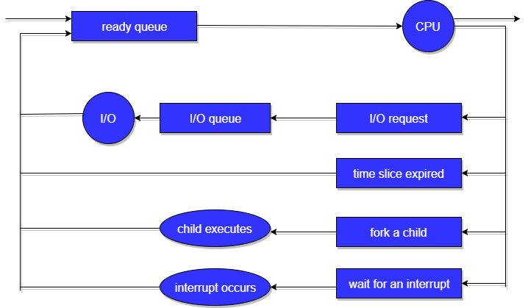
In the first two cases, the process eventually switches from the waiting state to the ready state, and is then put back in the ready queue. A process continues this cycle until it terminates, at which time it is removed from all queues and has its PCB and resources deallocated.
***

Scheduling Criteria:

Many criteria have been suggested for comparing CPU-scheduling algorithms. Which characteristics are used for comparison can make a substantial difference in which algorithm is judged to be best. The criteria include the following:

• CPU utilization. We want to keep the CPU as busy as possible. Conceptually, CPU utilization can range from 0 to 100 percent. In a real system, it should range from 40 percent (for a lightly loaded system) to 90 percent (for a heavily loaded system).

• Throughput: The number of processes that are completed per time unit, called throughput. For long processes, this rate may be one process per hour; for short transactions, it may be ten processes per second.

• Turnaround time. The intervalfrom the time of submission of a process to the time of completion is theturnaround time. Turnaround time is the sum of the periods spent waiting
to get into memory, waiting in the ready queue, executing on the CPU, anddoingI/O.

• Waiting time. Waitingtime is the sum of the periods spent waiting in the ready queue. The CPU-scheduling algorithm does not affect the amountof time during which a process executes or does I/O. It affects only theamount of time that a process spends waiting in the ready queue.

• Response time. In an interactive system, turnaround time may not bethe best criterion. Often, a process can produce some output fairly earlyand can continue computing new results while previous results are beingoutput to the user. Thus, another measure is the time from the submissionof a request until the first response is produced. This measure, calledresponse time, is the time it takes to start responding, not the time it takesto output the response. The turnaround time is generally limited by thespeed of the output device.

It is desirable to maximize CPU utilization and throughput and to minimizeturnaround time, waiting time, and response time.

***

Multilevel Queue Scheduling

Another class of scheduling algorithms has been created for situations inwhich processes are easily classified into different groups. For example, acommon division is made between foreground (interactive) processes andbackground(batch) processes.

A multilevel queue scheduling algorithm partitions the ready queue intoseveral separate queues (Figure 6.6). The processes are permanently assigned toone queue, generally based on some property of the process, such as memorysize, process priority, or process type. Each queue has its own schedulingalgorithm.

For example, separate queues might be used for foreground andbackground processes. The foreground queue might be scheduled by an RRalgorithm, while the background queue is scheduled by an FCFS algorithm.In addition, there must be scheduling among the queues, which is commonlyimplemented as fixed-priority pre-emptive scheduling.

Let’s look at an example of a multilevel queue scheduling algorithm withfive queues, listed below in order of priority:

1. System processes
2. Interactive processes
3. Interactive editing processes
4. Batch processes
5. Student processes

Each queue has absolute priority over lower-priority queues. If aninteractive editing process entered the ready queuewhile a batch processwasrunning, the batch process would be pre-empted.

Multilevel Feedback Queue Scheduling
If the multilevel queue scheduling algorithm is used, processesare permanently assigned to a queue when they enter the system. If thereare separate queues for foreground and background processes, for example,processes do not move from one queue to the other, since processes do notchange their foreground or background nature. This setup has the advantageof low scheduling overhead, but it is inflexible.

The multilevel feedback queue scheduling algorithm allowsa process tomove between queues. The idea is to separate processes accordingto the characteristics of their CPU bursts. If a process uses too much CPU time,it will be moved to a lower-priority queue. This scheme leaves I/O-bound andinteractive processes in the higher-priority queues. In addition, a process thatwaits too long in a lower-priority queue may be moved to a higher-priorityqueue. This form of aging prevents starvation.

For example, consider a multilevel feedback queue scheduler with threequeues, numbered from 0 to 2 (Figure 6.7). The scheduler first executes allprocesses in queue 0. Only when queue 0 is empty will it execute processesin queue 1. Similarly, processes in queue 2 will be executed only if queues 0and 1 are empty. A process that arrives for queue 1 will preempt a process inqueue 2. A process in queue 1 will in turn be preempted by a process arrivingfor queue 0.

Aprocess entering the ready queue is put in queue 0. A process in queue 0is given a time quantum of 8 milliseconds. If it does not finish within this time,it is moved to the tail of queue 1. If queue 0 is empty, the process at the headof queue 1 is given a quantum of 16 milliseconds. If it does not complete, it ispreempted and is put into queue 2. Processes in queue 2 are run on an FCFSbasis but are run only when queues 0 and 1 are empty.
In general, a multilevel feedback queue scheduler is defined by thefollowing parameters:
• The number of queues
• The scheduling algorithm for each queue
• The method used to determine when to upgrade a process to a higherpriorityqueue
• The method used to determine when to demote a process to a lowerpriorityqueue
• The method used to determine which queue a process will enter when thatprocess needs service
***
Thread Scheduling:

- The two types of threads are user-level and kernel-level threads.
- User-level threads are managed by a thread library, and the kernel is unaware of them.
- To run on a CPU, user-level threads must ultimately be mapped to an associated kernel-level thread, although this mapping may be indirect and may use a lightweight process (LWP).

Contention Scope:
- Processcontention scope(PCS)
- system-contention scope (SCS)

- One distinction between user-level and kernel-level threads lies in how they are scheduled.
- On systems implementing the many-to-one and many-to-many models, the thread library schedules user-level threads to run on an available LWP. This scheme is known as process contention scope(PCS), since competition for the CPU takes place among threads belonging to the same process.
- To decide which kernel-level thread to schedule onto a CPU, the kernel uses system-contention scope (SCS). Competition for the CPU with SCS scheduling takes place among all threads in the system.

Typically, PCS is done according to priority—the scheduler selects therunnable thread with the highest priority to run. User-level thread prioritiesare set by the programmer and are not adjusted by the thread library, althoughsome thread libraries may allow the programmer to change the priority ofa thread.

Pthread Scheduling:

Pthreadsidentifies the following contention scope values:
• PTHREAD_SCOPE_PROCESS schedules threads using PCS scheduling.
• PTHREAD_SCOPE_SYSTEM schedules threads using SCS scheduling.
On systems implementing the many-to-many model,
The PTHREAD_SCOPE_PROCESS policy schedules user-level threads onto availableLWPs.
The PTHREAD_SCOPE_SYSTEM schedulingpolicy will create and bind an LWP for each user-level thread on many-to-manysystems, effectively mapping threads using the one-to-one policy.

The Pthread IPC provides two functions for getting—and setting—thecontention scope policy:
• pthread_attr_setscope (pthread_attr_t *attr, int scope)
• pthread_attr_getscope (pthread_attr_t *attr, int *scope)
The first parameter for both functions contains a pointer to the attribute set forthe thread. The second parameter for the pthread_attr_setscope() functionis passed either the PTHREAD_SCOPE_SYSTEM or the PTHREAD_SCOPE_PROCESS value, indicating how the contention scope is to be set.
In the case ofpthread_attr_getscope(), this second parameter contains a pointer to anintvalue that is set to the current value of the contention scope. If an erroroccurs, each of these functions returns a nonzero value.

In Figure 6.8, we illustrate a Pthread scheduling API. The programfirst determines the existing contention scope and sets it toPTHREAD SCOPE SYSTEM. It then creates five separate threads that willrun using the SCS scheduling policy.
***
Multiple-Processor Scheduling:

IfmultipleCPUs are available, load sharingbecomes possible—but scheduling problems become correspondingly morecomplex. In Multi Processing Systems, We can then use any available processor to run any process in the queue.

Approaches to Multiple-Processor Scheduling

- A symmetric multiprocessing
- symmetric multiprocessing (SMP)

One approach to CPU scheduling in a multiprocessor system has all schedulingdecisions, I/O processing, and other system activities handled by a singleprocessor—the master server. The other processors execute only user code.This asymmetric multiprocessing is simple because only one processoraccesses the system data structures, reducing the need for data sharing.

A second approach uses symmetric multiprocessing (SMP), where eachprocessor is self-scheduling. All processes may be in a common ready queue, oreach processor may have its own private queue of ready processes. Regardless,scheduling proceeds by having the scheduler for each processor examine theready queue and select a process to execute.

Processor Affinity

The data most recently accessed by the process populatethe cache for the processor. As a result, successive memory accesses by theprocess are often satisfied in cache memory. if the process migrates to another processor then The contents of cache memorymust be invalidated for the first processor, and the cache for the secondprocessor must be repopulated. Because of the high cost of invalidating andrepopulating caches, most SMP systems try to avoid migration of processes from one processor to another and instead attempt to keep a process running on the same processor. This is known as processor affinity—that is, a process has an affinity for the processor on which it is currently running.

Processor affinity takes several forms. When an operating system has apolicy of attempting to keep a process running on the same processor—butnot guaranteeing that it will do so—we have a situation known as soft affinity.Here, the operating system will attempt to keep a process on a single processor,but it is possible for a process to migrate between processors.

In contrast, somesystems provide system calls that support hard affinity, thereby allowing aprocess to specify a subset of processors on which it may run. Many systemsprovide both soft and hard affinity.

The main-memory architecture of a system can affect processor affinityissues. Figure 6.9 illustrates an architecture featuring non-uniform memoryaccess (NUMA), in which a CPU has faster access to some parts of main memorythan to other parts. Typically, this occurs in systems containing combined CPUand memory boards. The CPUs on a board can access the memory on thatboard faster than they can access memory on other boards in the system.If the operating system’s CPU scheduler and memory-placement algorithmswork together, then a process that is assigned affinity to a particular CPUcan be allocated memory on the board where that CPU resides.

Load Balancing:

On SMP systems, it is important to keep the workload balanced among allprocessors to fully utilize the benefits of having more than one processor.

Load balancingattempts to keep the workload evenly distributed across all processors in anSMP system. It is important to note that load balancing is typically necessaryonly on systems where each processor has its own private queue of eligible processes to execute.

There are two general approaches to load balancing:
- push migration
- Pull migration.

In push migration, a specific task periodically checks theload on each processor and—if it finds an imbalance—evenly distributes theload by moving (or pushing) processes from overloaded to idle or less-busyprocessors.

In Pull migration when an idle processor pulls a waiting taskfrom a busy processor.

Push and pull migration need not be mutually exclusiveand are in fact often implemented in parallel on load-balancing systems.

Interestingly, load balancing often counteracts the benefits of processor affinity, That is, the benefit of keeping a processrunning on the same processor is that the process can take advantage of its databeing in that processor’s cache memory. Either pulling or pushing a processfrom one processor to another removes this benefit.
Multicore Processors:

Traditionally, SMP systems have allowed several threads to run concurrently byprovidingmultiple physical processors.However, a recent practice in computerhardware has been to place multiple processor cores on the same physical chip,resulting in a multicore processor. Each core maintains its architectural stateand thus appears to the operating system to be a separate physical processor.SMP systems that use multicore processors are faster and consume less powerthan systems in which each processor has its own physical chip.

Multicore processorsmaycomplicate scheduling issues.Researchers have discovered that when a processor accesses memory, it spends a significant amount of time waiting for the data to become available. This situation, known as a memory stall..Figure 6.10 illustrates a memory stall.

Many recent hardware designs have implementedmultithreaded processor cores in which two (or more) hardware threads areassigned to each core. That way, if one thread stalls while waiting for memory,the core can switch to another thread. Figure 6.11 illustrates a dual-threadedprocessor core on which the execution of thread 0 and the execution of thread 1are interleaved. From an operating-system perspective, each hardware threadappears as a logical processor that is available to run a software thread.

In general, there are two ways to multithread a processing core:
- Coarse-grained multithreading
- Fine-grained multithreading.

Incoarse-grained multithreading,a thread executes on a processor until a long-latency event such as a memorystall occurs. Because of the delay caused by the long-latency event, theprocessor must switch to another thread to begin execution. However, the cost of switching between threads is high, since the instruction pipeline mustbe flushed before the other thread can begin execution on the processor core.Once this new thread begins execution, it begins filling the pipeline with itsinstructions.
Fine-grained (or interleaved) multithreading switches betweenthreads at a much finer level of granularity—typically at the boundary of aninstruction cycle. However, the architectural design of fine-grained systemsincludes logic for thread switching. As a result,the cost of switching between threads is small.

A multithreaded multicore processor actually requires two different levels of scheduling:

In one level are the scheduling decisions thatmust be made by the operating system as it chooses which software thread torun on each hardware thread (logical processor).

In second level of scheduling specifies how each coredecides which hardware thread to run.

***
Scheduling algorithms:
There are various algorithms which are used by the Operating System to schedule the processes on the processor in an efficient way.

The Purpose of a Scheduling algorithm
- Maximum CPU utilization
- Fare allocation of CPU
- Maximum throughput
- Minimum turnaround time
- Minimum waiting time
- Minimum response time
There are the following algorithms which can be used to schedule the jobs.
1. First Come First Serve
It is the simplest algorithm to implement. The process with the minimal arrival time will get the CPU first. The lesser the arrival time, the sooner will the process gets the CPU. It is the non-preemptive type of scheduling.
2. Round Robin
In the Round Robin scheduling algorithm, the OS defines a time quantum (slice). All the processes will get executed in the cyclic way. Each of the process will get the CPU for a small amount of time (called time quantum) and then get back to the ready queue to wait for its next turn. It is a preemptive type of scheduling.
3. Shortest Job First
The job with the shortest burst time will get the CPU first. The lesser the burst time, the sooner will the process get the CPU. It is the non-preemptive type of scheduling.
4. Shortest remaining time first
It is the preemptive form of SJF. In this algorithm, the OS schedules the Job according to the remaining time of the execution.
5. Priority based scheduling
In this algorithm, the priority will be assigned to each of the processes. The higher the priority, the sooner will the process get the CPU. If the priority of the two processes is same then they will be scheduled according to their arrival time.
6. Highest Response Ratio Next
In this scheduling Algorithm, the process with highest response ratio will be scheduled next. This reduces the starvation in the system.
FCFS Scheduling
First come first serve (FCFS) scheduling algorithm simply schedules the jobs according to their arrival time. The job which comes first in the ready queue will get the CPU first. The lesser the arrival time of the job, the sooner will the job get the CPU. FCFS scheduling may cause the problem of starvation if the burst time of the first process is the longest among all the jobs.
Advantages of FCFS
- Simple
- Easy
- First come, First serv
Disadvantages of FCFS
- The scheduling method is non preemptive, the process will run to the completion.
- Due to the non-preemptive nature of the algorithm, the problem of starvation may occur.
- Although it is easy to implement, but it is poor in performance since the average waiting time is higher as compare to other scheduling algorithms.
Example
Let's take an example of The FCFS scheduling algorithm. In the Following schedule, there are 5 processes with process ID P0, P1, P2, P3 and P4. P0 arrives at time 0, P1 at time 1, P2 at time 2, P3 arrives at time 3 and Process P4 arrives at time 4 in the ready queue. The processes and their respective Arrival and Burst time are given in the following table.
The Turnaround time and the waiting time are calculated by using the following formula.
- Turn Around Time = Completion Time - Arrival Time
- Waiting Time = Turnaround time - Burst Time
The average waiting Time is determined by summing the respective waiting time of all the processes and divided the sum by the total number of processes.
Process ID | Arrival Time | Burst Time | Completion Time | Turn Around Time | Waiting Time
0 | 0 | 2 | 2 | 2 | 0
1 | 1 | 6 | 8 | 7 | 1
2 | 2 | 4 | 12 | 10 | 6
3 | 3 | 9 | 21 | 18 | 9
4 | 6 | 12 | 33 | 29 | 17
Avg Waiting Time=31/5
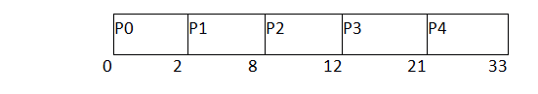
(Gantt chart)

Convoy Effect in FCFS
FCFS may suffer from the convoy effect if the burst time of the first job is the highest among all. As in the real life, if a convoy is passing through the road then the other persons may get blocked until it passes completely. This can be simulated in the Operating System also.
If the CPU gets the processes of the higher burst time at the front end of the ready queue then the processes of lower burst time may get blocked which means they may never get the CPU if the job in the execution has a very high burst time. This is called convoy effect or starvation.
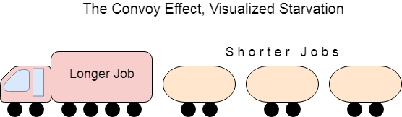
Example
In the Example, We have 3 processes named as P1, P2 and P3. The Burt Time of process P1 is highest.
The Turnaround time and the waiting time in the following table, are calculated by the formula,
- Turn Around Time = Completion Time - Arrival Time
- Waiting Time = Turn Around Time - Burst Time
In the First scenario, The Process P1 arrives at the first in the queue although; the burst time of the process is the highest among all. Since, the Scheduling algorithm, we are following is FCFS hence the CPU will execute the Process P1 first.
In this schedule, the average waiting time of the system will be very high. That is because of the convoy effect. The other processes P2, P3 have to wait for their turn for 40 units of time although their burst time is very low. This schedule suffers from starvation.

Exception Handling in Java - Javatpoint
Process ID | Arrival Time | Burst Time | Completion Time | Turn Around Time | Waiting Time
1 | 0 | 40 | 40 | 40 | 0
2 | 1 | 3 | 43 | 42 | 39
3 | 1 | 1 | 44 | 43 | 42
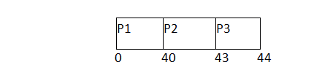
Avg waiting Time = 81/3
In the Second scenario, If Process P1 would have arrived at the last of the queue and the other processes P2 and P3 at earlier then the problem of starvation would not be there.
Following example shows the deviation in the waiting times of both the scenarios. Although the length of the schedule is same that is 44 units but the waiting time will be lesser in this schedule.
Process ID | Arrival Time | Burst Time | Completion Time | Turn Around Time | Waiting Time
1 | 1 | 40 | 44 | 43 | 3
2 | 0 | 3 | 3 | 3 | 0
3 | 0 | 1 | 4 | 4 | 3
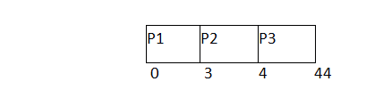
Avg Waiting Time=6/3
Shortest Job First (SJF) Scheduling
Till now, we were scheduling the processes according to their arrival time (in FCFS scheduling). However, SJF scheduling algorithm, schedules the processes according to their burst time.
In SJF scheduling, the process with the lowest burst time, among the list of available processes in the ready queue, is going to be scheduled next.
However, it is very difficult to predict the burst time needed for a process hence this algorithm is very difficult to implement in the system.
Advantages of SJF
- Maximum throughput
- Minimum average waiting and turnaround time
Disadvantages of SJF
- May suffer with the problem of starvation
- It is not implementable because the exact Burst time for a process can't be known in advance.
There are different techniques available by which, the CPU burst time of the process can be determined. We will discuss them later in detail.
Example
In the following example, there are five jobs named as P1, P2, P3, P4 and P5. Their arrival time and burst time are given in the table below.
PID | Arrival Time | Burst Time | Completion Time | Turn Around Time | Waiting Time
1 | 1 | 7 | 8 | 7 | 0
2 | 3 | 3 | 13 | 10 | 7
3 | 6 | 2 | 10 | 4 | 2
4 | 7 | 10 | 31 | 24 | 14
5 | 9 | 8 | 21 | 12 | 4
Since, No Process arrives at time 0 hence; there will be an empty slot in the Gantt chart from time 0 to 1 (the time at which the first process arrives).
According to the algorithm, the OS schedules the process which is having the lowest burst time among the available processes in the ready queue.
Till now, we have only one process in the ready queue hence the scheduler will schedule this to the processor no matter what is its burst time.
This will be executed till 8 units of time. Till then we have three more processes arrived in the ready queue hence the scheduler will choose the process with the lowest burst time.
Among the processes given in the table, P3 will be executed next since it is having the lowest burst time among all the available processes.
So that's how the procedure will go on in shortest job first (SJF) scheduling algorithm.
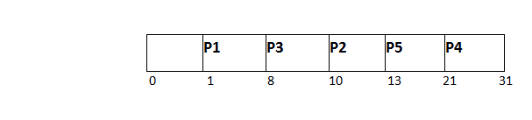
Avg Waiting Time = 27/5
Shortest Remaining Time First (SRTF) Scheduling Algorithm
This Algorithm is the preemptive version of SJF scheduling. In SRTF, the execution of the process can be stopped after certain amount of time. At the arrival of every process, the short term scheduler schedules the process with the least remaining burst time among the list of available processes and the running process.
Once all the processes are available in the ready queue, No preemption will be done and the algorithm will work as SJF scheduling. The context of the process is saved in the Process Control Block when the process is removed from the execution and the next process is scheduled. This PCB is accessed on the next execution of this process.
Example
In this Example, there are five jobs P1, P2, P3, P4, P5 and P6. Their arrival time and burst time are given below in the table.
Process ID | Arrival Time | Burst Time | Completion Time | Turn Around Time | Waiting Time | Response Time
1 | 0 | 8 | 20 | 20 | 12 | 0
2 | 1 | 4 | 10 | 9 | 5 | 1
3 | 2 | 2 | 4 | 2 | 0 | 2
4 | 3 | 1 | 5 | 2 | 1 | 4
5 | 4 | 3 | 13 | 9 | 6 | 10
6 | 5 | 2 | 7 | 2 | 0 | 5
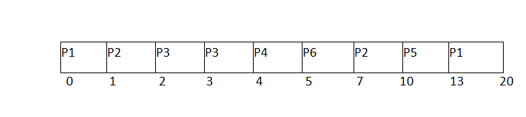
Avg Waiting Time = 24/6
The Gantt chart is prepared according to the arrival and burst time given in the table.
- Since, at time 0, the only available process is P1 with CPU burst time 8. This is the only available process in the list therefore it is scheduled.
- The next process arrives at time unit 1. Since the algorithm we are using is SRTF which is a preemptive one, the current execution is stopped and the scheduler checks for the process with the least burst time.
Till now, there are two processes available in the ready queue. The OS has executed P1 for one unit of time till now; the remaining burst time of P1 is 7 units. The burst time of Process P2 is 4 units. Hence Process P2 is scheduled on the CPU according to the algorithm.
- The next process P3 arrives at time unit 2. At this time, the execution of process P3 is stopped and the process with the least remaining burst time is searched. Since the process P3 has 2 unit of burst time hence it will be given priority over others.
- The Next Process P4 arrives at time unit 3. At this arrival, the scheduler will stop the execution of P4 and check which process is having least burst time among the available processes (P1, P2, P3 and P4). P1 and P2 are having the remaining burst time 7 units and 3 units respectively.
P3 and P4 are having the remaining burst time 1 unit each. Since, both are equal hence the scheduling will be done according to their arrival time. P3 arrives earlier than P4 and therefore it will be scheduled again.
- The Next Process P5 arrives at time unit 4. Till this time, the Process P3 has completed its execution and it is no more in the list. The scheduler will compare the remaining burst time of all the available processes. Since the burst time of process P4 is 1 which is least among all hence this will be scheduled.
- The Next Process P6 arrives at time unit 5, till this time, the Process P4 has completed its execution. We have 4 available processes till now, that are P1 (7), P2 (3), P5 (3) and P6 (2). The Burst time of P6 is the least among all hence P6 is scheduled. Since, now, all the processes are available hence the algorithm will now work same as SJF. P6 will be executed till its completion and then the process with the least remaining time will be scheduled.
Once all the processes arrive, No preemption is done and the algorithm will work as SJF. Q. Given the arrival time and burst time of 3 jobs in the table below. Calculate the Average waiting time of the system.
Process ID | Arrival Time | Burst Time | Completion Time | Turn Around Time | Waiting Time
1 | 0 | 9 | 13 | 13 | 4
2 | 1 | 4 | 5 | 4 | 0
3 | 2 | 9 | 22 | 20 | 11
There are three jobs P1, P2 and P3. P1 arrives at time unit 0; it will be scheduled first for the time until the next process arrives. P2 arrives at 1 unit of time. Its burst time is 4 units which is least among the jobs in the queue. Hence it will be scheduled next.
At time 2, P3 will arrive with burst time 9. Since remaining burst time of P2 is 3 units which are least among the available jobs. Hence the processor will continue its execution till its completion. Because all the jobs have been arrived so no preemption will be done now and all the jobs will be executed till the completion according to SJF.
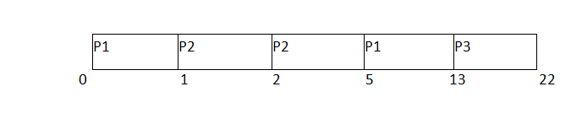
Avg Waiting Time = (4+0+11)/3 = 5 units

Round Robin Scheduling Algorithm
Round Robin scheduling algorithm is one of the most popular scheduling algorithm which can actually be implemented in most of the operating systems. This is the preemptive version of first come first serve scheduling. The Algorithm focuses on Time Sharing. In this algorithm, every process gets executed in a cyclic way. A certain time slice is defined in the system which is called time quantum. Each process present in the ready queue is assigned the CPU for that time quantum, if the execution of the process is completed during that time then the process will terminate else the process will go back to the ready queue and waits for the next turn to complete the execution.
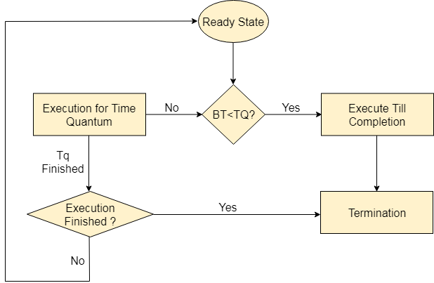

Advantages
- It can be actually implementable in the system because it is not depending on the burst time.
- It doesn't suffer from the problem of starvation or convoy effect.
- All the jobs get a fare allocation of CPU.

Disadvantages
- The higher the time quantum, the higher the response time in the system.
- The lower the time quantum, the higher the context switching overhead in the system.
- Deciding a perfect time quantum is really a very difficult task in the system.

RR Scheduling Example
In the following example, there are six processes named as P1, P2, P3, P4, P5 and P6. Their arrival time and burst time are given below in the table. The time quantum of the system is 4 units.
Process ID | Arrival Time | Burst Time
1 | 0 | 5
2 | 1 | 6
3 | 2 | 3
4 | 3 | 1
5 | 4 | 5
6 | 6 | 4
According to the algorithm, we have to maintain the ready queue and the Gantt chart. The structure of both the data structures will be changed after every scheduling.

Ready Queue:
Initially, at time 0, process P1 arrives which will be scheduled for the time slice 4 units. Hence in the ready queue, there will be only one process P1 at starting with CPU burst time 5 units.
P1
5

GANTT chart
The P1 will be executed for 4 units first.
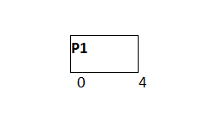

Ready Queue
Meanwhile the execution of P1, four more processes P2, P3, P4 and P5 arrives in the ready queue. P1 has not completed yet, it needs another 1 unit of time hence it will also be added back to the ready queue.
P2 | P3 | P4 | P5 | P1
6 | 3 | 1 | 5 | 1

GANTT chart
After P1, P2 will be executed for 4 units of time which is shown in the Gantt chart.
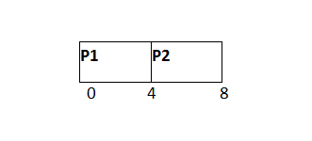Ready Queue
During the execution of P2, one more process P6 is arrived in the ready queue. Since P2 has not completed yet hence, P2 will also be added back to the ready queue with the remaining burst time 2 units.
P3 | P4 | P5 | P1 | P6 | P2
3 | 1 | 5 | 1 | 4 | 2
GANTT chart
After P1 and P2, P3 will get executed for 3 units of time since its CPU burst time is only 3 seconds.
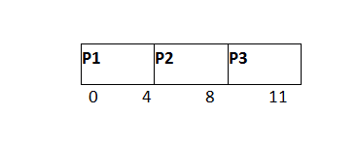
Ready Queue
Since P3 has been completed, hence it will be terminated and not be added to the ready queue. The next process will be executed is P4.
P4 | P5 | P1 | P6 | P2
1 | 5 | 1 | 4 | 2
GANTT chart
After, P1, P2 and P3, P4 will get executed. Its burst time is only 1 unit which is lesser then the time quantum hence it will be completed.
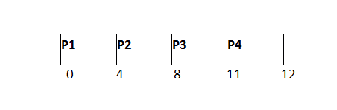
Ready Queue
The next process in the ready queue is P5 with 5 units of burst time. Since P4 is completed hence it will not be added back to the queue.
P5 | P1 | P6 | P2
5 | 1 | 4 | 2
GANTT chart
P5 will be executed for the whole time slice because it requires 5 units of burst time which is higher than the time slice.
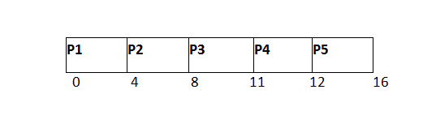
Ready Queue
P5 has not been completed yet; it will be added back to the queue with the remaining burst time of 1 unit.
P1 | P6 | P2 | P5
1 | 4 | 2 | 1
GANTT Chart
The process P1 will be given the next turn to complete its execution. Since it only requires 1 unit of burst time hence it will be completed.
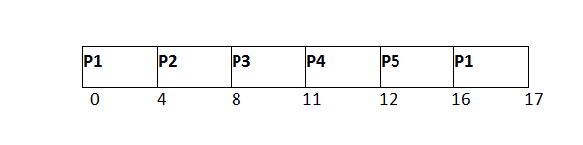
Ready Queue
P1 is completed and will not be added back to the ready queue. The next process P6 requires only 4 units of burst time and it will be executed next.
P6 | P2 | P5
4 | 2 | 1
GANTT chart
P6 will be executed for 4 units of time till completion.
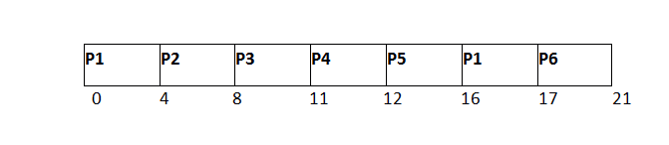
Ready Queue
Since P6 is completed, hence it will not be added again to the queue. There are only two processes present in the ready queue. The Next process P2 requires only 2 units of time.
P2 | P5
2 | 1
GANTT Chart
P2 will get executed again, since it only requires only 2 units of time hence this will be completed.
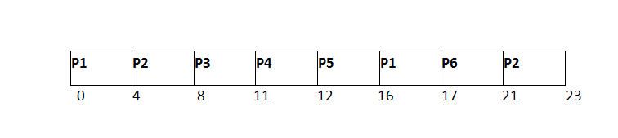
Ready Queue
Now, the only available process in the queue is P5 which requires 1 unit of burst time. Since the time slice is of 4 units hence it will be completed in the next burst.
P5
1
GANTT chart
P5 will get executed till completion.
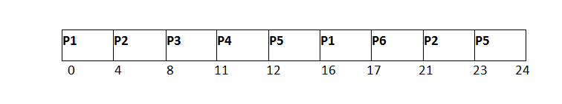The completion time, Turnaround time and waiting time will be calculated as shown in the table below.
As, we know,
- Turn Around Time = Completion Time - Arrival Time
- Waiting Time = Turn Around Time - Burst Time

Process ID | Arrival Time | Burst Time | Completion Time | Turn Around Time | Waiting Time
1 | 0 | 5 | 17 | 17 | 12
2 | 1 | 6 | 23 | 22 | 16
3 | 2 | 3 | 11 | 9 | 6
4 | 3 | 1 | 12 | 9 | 8
5 | 4 | 5 | 24 | 20 | 15
6 | 6 | 4 | 21 | 15 | 11
Avg Waiting Time = (12+16+6+8+15+11)/6 = 76/6 units
Highest Response Ratio Next (HRRN) Scheduling
Highest Response Ratio Next (HRNN) is one of the most optimal scheduling algorithms. This is a non-preemptive algorithm in which, the scheduling is done on the basis of an extra parameter called Response Ratio. A Response Ratio is calculated for each of the available jobs and the Job with the highest response ratio is given priority over the others.
Response Ratio is calculated by the given formula.
- Response Ratio = (W+S)/S
Where,
- W → Waiting Time
- S → Service Time or Burst Time
If we look at the formula, we will notice that the job with the shorter burst time will be given priority but it is also including an extra factor called waiting time. Since,
- HRNN α W
- HRNN α (1/S)
Hence,
- This algorithm not only favors shorter job but it also concern the waiting time of the longer jobs.
- Its mode is non preemptive hence context switching is minimal in this algorithm.

HRNN Example
In the following example, there are 5 processes given. Their arrival time and Burst Time are given in the table.
Process ID | Arrival Time | Burst Time
0 | 0 | 3
1 | 2 | 5
2 | 4 | 4
3 | 6 | 1
4 | 8 | 2
At time 0, The Process P0 arrives with the CPU burst time of 3 units. Since it is the only process arrived till now hence this will get scheduled immediately.
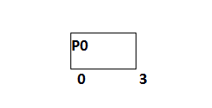
P0 is executed for 3 units, meanwhile, only one process P1 arrives at time 3. This will get scheduled immediately since the OS doesn't have a choice.
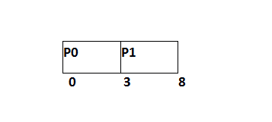
P1 is executed for 5 units. Meanwhile, all the processes get available. We have to calculate the Response Ratio for all the remaining jobs.
- RR (P2) = ((8-4) +4)/4 = 2
- RR (P3) = (2+1)/1 = 3
- RR (P4) = (0+2)/2 = 1
Since, the Response ratio of P3 is higher hence P3 will be scheduled first.
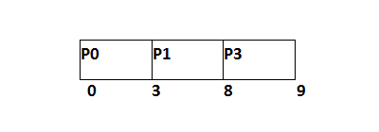
P3 is scheduled for 1 unit. The next available processes are P2 and P4. Let's calculate their Response ratio.
- RR ( P2) = (5+4)/4 = 2.25
- RR (P4) = (1+2)/2 = 1.5
The response ratio of P2 is higher hence P2 will be scheduled.
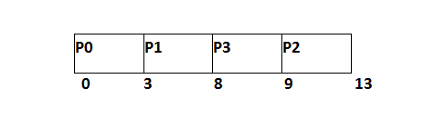
Now, the only available process is P4 with the burst time of 2 units, since there is no other process available hence this will be scheduled.
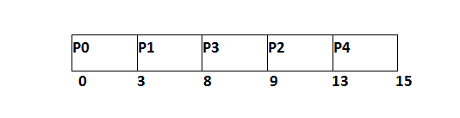
Process ID | Arrival Time | Burst Time | Completion Time | Turn Around Time | Waiting Time
0 | 0 | 3 | 3 | 3 | 0
1 | 2 | 5 | 8 | 6 | 1
2 | 4 | 4 | 13 | 9 | 5
3 | 6 | 1 | 9 | 3 | 2
4 | 8 | 2 | 15 | 7 | 5
Average Waiting Time = 13/5
Priority Scheduling
In Priority scheduling, there is a priority number assigned to each process. In some systems, the lower the number, the higher the priority. While, in the others, the higher the number, the higher will be the priority. The Process with the higher priority among the available processes is given the CPU. There are two types of priority scheduling algorithm exists. One is Preemptive priority scheduling while the other is Non Preemptive Priority scheduling.
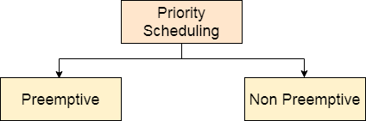
The priority number assigned to each of the process may or may not vary. If the priority number doesn't change itself throughout the process, it is called static priority, while if it keeps changing itself at the regular intervals, it is called dynamic priority.
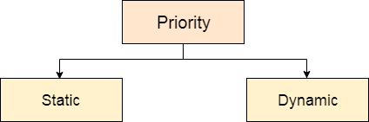
Non Preemptive Priority Scheduling
In the Non Preemptive Priority scheduling, The Processes are scheduled according to the priority number assigned to them. Once the process gets scheduled, it will run till the completion. Generally, the lower the priority number, the higher is the priority of the process. The people might get confused with the priority numbers, hence in the GATE, there clearly mention which one is the highest priority and which one is the lowest one.
Example
In the Example, there are 7 processes P1, P2, P3, P4, P5, P6 and P7. Their priorities, Arrival Time and burst time are given in the table.
Process ID | Priority | Arrival Time | Burst Time
1 | 2 | 0 | 3
2 | 6 | 2 | 5
3 | 3 | 1 | 4
4 | 5 | 4 | 2
5 | 7 | 6 | 9
6 | 4 | 5 | 4
7 | 10 | 7 | 10
We can prepare the Gantt chart according to the Non Preemptive priority scheduling.
The Process P1 arrives at time 0 with the burst time of 3 units and the priority number 2. Since No other process has arrived till now hence the OS will schedule it immediately.
Meanwhile the execution of P1, two more Processes P2 and P3 are arrived. Since the priority of P3 is 3 hence the CPU will execute P3 over P2.
Meanwhile the execution of P3, All the processes get available in the ready queue. The Process with the lowest priority number will be given the priority. Since P6 has priority number assigned as 4 hence it will be executed just after P3.
After P6, P4 has the least priority number among the available processes; it will get executed for the whole burst time.
Since all the jobs are available in the ready queue hence All the Jobs will get executed according to their priorities. If two jobs have similar priority number assigned to them, the one with the least arrival time will be executed.
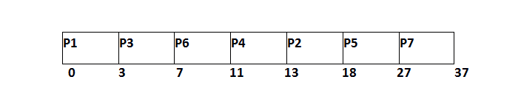
From the GANTT Chart prepared, we can determine the completion time of every process. The turnaround time, waiting time and response time will be determined.
- Turn Around Time = Completion Time - Arrival Time
- Waiting Time = Turn Around Time - Burst Time
Process Id | Priority | Arrival Time | Burst Time | Completion Time | Turnaround Time | Waiting Time | Response Time
1 | 2 | 0 | 3 | 3 | 3 | 0 | 0
2 | 6 | 2 | 5 | 18 | 16 | 11 | 13
3 | 3 | 1 | 4 | 7 | 6 | 2 | 3
4 | 5 | 4 | 2 | 13 | 9 | 7 | 11
5 | 7 | 6 | 9 | 27 | 21 | 12 | 18
6 | 4 | 5 | 4 | 11 | 6 | 2 | 7
7 | 10 | 7 | 10 | 37 | 30 | 18 | 27
Avg Waiting Time = (0+11+2+7+12+2+18)/7 = 52/7 units
Preemptive Priority Scheduling
In Preemptive Priority Scheduling, at the time of arrival of a process in the ready queue, its Priority is compared with the priority of the other processes present in the ready queue as well as with the one which is being executed by the CPU at that point of time. The One with the highest priority among all the available processes will be given the CPU next.
The difference between preemptive priority scheduling and non preemptive priority scheduling is that, in the preemptive priority scheduling, the job which is being executed can be stopped at the arrival of a higher priority job.
Once all the jobs get available in the ready queue, the algorithm will behave as non-preemptive priority scheduling, which means the job scheduled will run till the completion and no preemption will be done.
Example
There are 7 processes P1, P2, P3, P4, P5, P6 and P7 given. Their respective priorities, Arrival Times and Burst times are given in the table below.
Process Id | Priority | Arrival Time | Burst Time
1 | 2(L) | 0 | 1
2 | 6 | 1 | 7
3 | 3 | 2 | 3
4 | 5 | 3 | 6
5 | 4 | 4 | 5
6 | 10(H) | 5 | 15
7 | 9 | 15 | 8
GANTT chart Preparation
At time 0, P1 arrives with the burst time of 1 units and priority 2. Since no other process is available hence this will be scheduled till next job arrives or its completion (whichever is lesser).
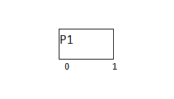
At time 1, P2 arrives. P1 has completed its execution and no other process is available at this time hence the Operating system has to schedule it regardless of the priority assigned to it.
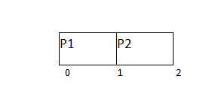The Next process P3 arrives at time unit 2, the priority of P3 is higher to P2. Hence the execution of P2 will be stopped and P3 will be scheduled on the CPU.
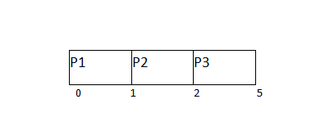
During the execution of P3, three more processes P4, P5 and P6 becomes available. Since, all these three have the priority lower to the process in execution so PS can't preempt the process. P3 will complete its execution and then P5 will be scheduled with the priority highest among the available processes.
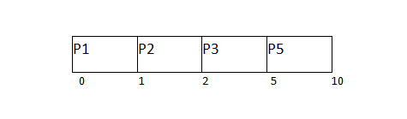
Meanwhile the execution of P5, all the processes got available in the ready queue. At this point, the algorithm will start behaving as Non Preemptive Priority Scheduling. Hence now, once all the processes get available in the ready queue, the OS just took the process with the highest priority and execute that process till completion. In this case, P4 will be scheduled and will be executed till the completion.
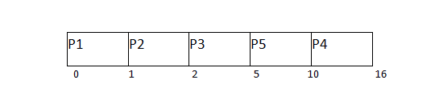
Since P4 is completed, the other process with the highest priority available in the ready queue is P2. Hence P2 will be scheduled next.
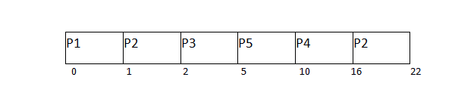
P2 is given the CPU till the completion. Since its remaining burst time is 6 units hence P7 will be scheduled after this.
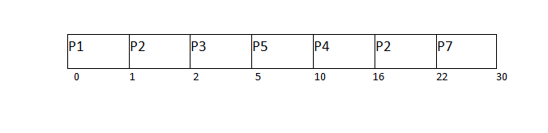
The only remaining process is P6 with the least priority, the Operating System has no choice unless of executing it. This will be executed at the last.
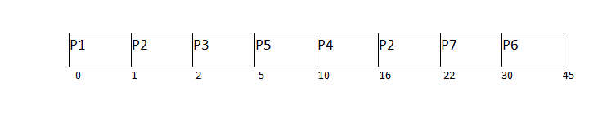The Completion Time of each process is determined with the help of GANTT chart. The turnaround time and the waiting time can be calculated by the following formula.
- Turnaround Time = Completion Time - Arrival Time
- Waiting Time = Turn Around Time - Burst Time
Process Id | Priority | Arrival Time | Burst Time | Completion Time | Turn around Time | Waiting Time
1 | 2 | 0 | 1 | 1 | 1 | 0
2 | 6 | 1 | 7 | 22 | 21 | 14
3 | 3 | 2 | 3 | 5 | 3 | 0
4 | 5 | 3 | 6 | 16 | 13 | 7
5 | 4 | 4 | 5 | 10 | 6 | 1
6 | 10 | 5 | 15 | 45 | 40 | 25
7 | 9 | 6 | 8 | 30 | 24 | 16

***

References:

Abraham Silberschatz, Greg Gagne, and Peter Baer Galvin, "Operating System Concepts, Ninth Edition "

